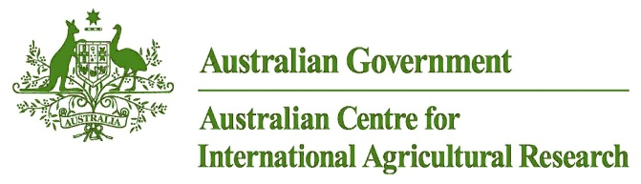

|  |  |
| --- | --- |
|  | Annual report |
| project | Developing the cocoa value chain in Bougainville |
| project number | **HORT/2014/094** |
| period of report | **2018-2019** |
| prepared by | Joe Yabom, PNGCCIL, |
| co-authors/ contributors/ collaborators | Silas Paisi- FEO South Bougainville  Bruno Batari- FEO Central Bougainville  Julie Rereve- FEO North Bougainville |

# Progress summary

The specific aim of Cocoa Baords involvement in this project as one of the major partners is to improve the profitability and vitality of smallholder cocoa farming families and communities in Bougainville through the aim of strengthening the workforce under this project through resourcing, training, research and Development to deliver professionally to the wider cocoa farming communities and at the same time advice the ABG and the ACIAR through Sydney University of our research outcomes and impacts observed.

Cocoa Board delivered through the following objectives:

1: To improve the productivity, profitability and sustainability of cocoa farming and related enterprises;

2: To foster innovation and enterprise development at community level; and

3: To strengthen value chains for cocoa and associated horticultural products

At this time of the project life, some activities have been fully achieved whilst some are nearing completion. For budwood gardens and nurseries, they both go hand in hand but the former has to be established earlier than the latter in order to have a good supply of bud sticks for budding operations. It’s also a coincidence that it happens that way as we prioritise in terms of funding limitations that we cannot do everything at ones. Therefore, all budwood gardens are now fully established whilst the nurseries are in the process of erection. But during that space, we trained the farmers to set up village nurseries which we saw a good outcome. Soil sampling has been done and organising samples to be sent for soil analysis. Demo plot establishment is one main highlight for this reporting period and other trainings were also conducted for farmers all throughout June 2018 to June 2019.

# Achievement against activities and outputs/milestones

|  |  |  |  |  |
| --- | --- | --- | --- | --- |
| No. | Activity | Outputs/  milestones | Due date of output/ milestone | Progress to June 2019 |
| 1.4 | Training of DPI Senior Facilitators, District Officers, and selected VEWs | Train 12 Senior DPI Facilitators, (at MCA), then 52 District Officers and 33 village level specialists in cocoa, food crops, livestock and health | completed | 1 x CCI officer trained at MARS Indonesia including a UNRE staff funded under CCIs allocation.  33 VEWs, 3 Hub coordinators and 3 CCI Project staff with some DPI officers trained on Sustainable Livelihood, IPDM, CPBM, Clones, BWG and Nursery set up as well as two business modules- small enterprises and record keeping and decision making. |
| 1.5 | Establish village budwood gardens and Nurseries | Establish 33 village budwood gardens | Completed | This activity has been achieved but infilling due to deaths to plants is ongoing. |
| Establish 33 Nurseries | On going | 16 Nurseries were already set up and supplying PPAP project but another 17 nurseries are in the process of erection. 17 Shade cloths were purchased and delivered to farmers to start erecting their 5,000 capacity nurseries and can extend them if there is a need to do so. |
| 1.6 | Evaluate soils and compost and fertiliser requirements | Sample soils and establish composting trials linked to resource centres | 7/2016-2018 | Soil sampling was completed with 8 samples each from each region and waiting response from soil labs to compare quotes before sending. It is highly unlikely that PNG labs will be utilised due to high costs involved as well as takes a long time before results a received as experienced by the SMCN project so a better option would be to send them to India. |
| 1.7 | Establish IPDM demonstration plots | Establish 33 IPDM plots | 7/2016-2018 | 23 demo plots were established and 10 more to reach the target of 33 demo plots. |
| 1.9 | Farmer Training | Training Established in 33 villages.  Communication and outreach ( Radio, social media, Bougainville Bulettin, Newsletter, etc | 7/2016-2018 | Farmer trainings conducted during this reporting period are;   1. Compost making and application (9 trainings so far) 2. Demo plot set up ( 23 trainings) 3. Bud grafting (11 trainings) 4. Village nursery set up ( 28 trainings) |
|  |  |  |  |  |
| 3.1 | Support the establishments of DPI Regional Hubs in Bougainville | Selected facilitators trained at the MARS cocoa academy so DPI has a network of well supported research hubs staffed by trained scientists and technicians | Dec -2021 | The South Hub station is fully established with a 10,000 capacity nursery, a budwood garden, a new clone block and a shed built to store tools and chemical and at the same time used as a compost house. We call it a combo shed.  We also have a full time officer manning the station.  For central, there is no hub station so we resorted to using one of our hard working VEWs (George Tonai) to set up the Solar dryer, budwood garden and nursery erection is in progress. The demo plot and compost hut were also established in a farmers block living next to George Tonai . A bicycle was also purchased for him to help him reach out to his other farmers due to the remoteness of their blocks.  North also is facing similar situation like the Central so another hardworking VEW ( Benjamin) at Siing was chosen and had the budwood garden established, nursery established, Demo block and the compost hut as well. |
| 3.4 | Support economic development through enterprise development | Village communities establish diverse enterprises based around cocoa farming- nurseries, fermentation and drying, marketing, compost, block sanitation…. | 7/2016-12/2021 | Training Programs are now run by the VEWs and supported by the DEOs.  Budders who were trained through this project are now been time to time contracted to do budding in other commercial nurseries. |
|  |  |  |  |  |
| 4.1 | Improve quality through better postharvest handling, fermentation and drying | Establish and evaluate cocoa drying and fermenting equipment.  Guidelines for cocoa fermentation and drying  Communities adapt, build and maintain new fermentaries and dryers  Cocoa quality monitoring becomes routine | 1/2017-12/2021 | dryers built already but there is one more to go for the South. Continuos training and awareness done by Julie of North Bougainville as she makes chocolates and farmers take their own samples over for testing to see if they are producing quality cocoa.  Silas is also working in partnership with the Field Services of Cocoa Board to carry out awareness and inspect cocoa fermentaries. |
| 4.3 | Extension, Education and capacity Building | DPI Officers trained in cocoa management | 7/2017- 12/2021 | DPI officers together with VEWs were already trained in 2017 but continue to learn new technologies through collaborative efforts with the project staff and the DPI officers. |
| 4.4 | Link resource centres with schools/technical colleges to facilitate technology/skills training and transfer | IPDM plots located near schools/colleges | 7/2016-12/2021 | Negotiations with the curriculum officer to roll out program done already. |
| Cocoa management, food crops, livestock, business and health included in, and enriches, curriculum | Pilot training for teachers still pending. Will be roll out after the curriculum committee seats for a meeting and gives a go ahead. Sample text books were being distributed to them upon their request. |
| 4.5 | Chocolate Festivals and field Days | Annual events including chocolate judging, farming and health training | 7/2016-12/2021 | Preparations for the upcoming event in August 2019 is underway with printing of new posters, seeding of poly bags, budding of rootstocks, etc. |
| 5.0 | New Clones establishment | To discover clones from the 20 selected that can withstand high rainfall occurrances | Ongoing | Out of the First Lot of 400 plantings had a high mortality rate that we lost about 2/3s of the block due to continuous raining during field budding time.  A total of 1000 rootstocks were budded to get get the best 400 out of the 1000 for field planting. Clones are about a month old in the nursery. |
| 6.0 | Others |  |  | Built a shed at Arawa to store tools, materials and chemicals |

# Project Outcomes and Impacts

The outcomes of the project are gradually been achieved and the impacts are seen at the village level as the interest on cocoa husbandry is gaining momentum with more farmers enquiring for more trainings to be conducted and farmers also putting into practice what they learnt. This can be seen in the clearing of new site to plant cocoa, rehabilitation of old blocks and building of low cost village nurseries.

## Research Outcomes

We have proven the use of ice block plastics as budding tapes and kiwi knives as budding knives that the strike rate results are just the same compared to using the right tools and materials.

We are yet to get our results for the soil sampling as well as the new clone establishment that is yet to be established. Materials are currently in the nursery and waiting for maturity before being transplanted.

## Scientific impacts

The idea of using ice block plastics and kiwi knives is now widely used in Bougainville even in some commercial nurseries as buddy tape and budding knives are very costly.

We also did awareness and trained people on the use of the knife and the plastic during the 2017 Chocolate Festival in Arawa including the PPAP team. The PPAP officers later reported to their management that people were already into using these cheap means but then they took it as their idea and published it in the dailies for their own glory without acknowledging the project and people behind it.

## Capacity impacts

The three (3) project staffs are well trained and now have the ability to work independently and professionally. They also have imparted more skills and knowledge to their VEWs and their VEWS continue to deliver the same information and skills learnt into their communities.

## Community outcomes and impacts

The project has done a lot in terms of cocoa engagements with the people, as through this project the Cocoa technologies were able to be disseminated through to the community level. The effect may be termed as a ripple effect but the impact is like a tsunami that has caused people to see the importance of cocoa quality that starts from the soils, planting materials to post harvest and finally marketing.

Communities that are outside the project selected VAs has also invited us to conduct awareness about how they can benefit from out trainings. Therefore we have held focus group meetings with these communities to pick out where their basic common need arises.

After this we have always invited interested farmers to attend our field trainings where possible.

### Economic impacts

A better survey can be employed to measure the economic impacts of the people who are direct recipients of this project esp the 33 VEWs. But through observation, it can be clearly seen that these VEWs are leading their farmers by example and have their blocks rehabilitated to see the trees come into bearing again, budwood gardens and nursery are also commercialised. Meaning that the economic status of these farmers have risen to another level but needs to be evaluated to determine the rise in the living standards.

.

### Social impacts

Village chiefs are requesting for training on cocoa technologies to be taken to their villages, even those that were not included in the project.

A number of the farmers whom we trained have been equipped with skills and knowledge where to some extent have used these skills to find employment in other cocoa nurseries as budders. Also some youths who roam around in the communities now form groups and are hired by cocoa farmers to prune cocoa blocks to earn some income. Bulk of these youths often visit our regional hub station at Buin for more advice.

### Environmental impacts

Under planting and cocoa rehabilitation training also gave our farmers a better option to boost production from their old senile cocoa trees where as in the past they used to cut new areas to plant new cocoa plantations which lead to devastation of the flora and fauna. Therefore most our farmers now used old and existing blocks to under plant and rehabilitate to get more production rather than cutting down new forest to plant cocoa.

### Policy impact

The policies on good quality bean production that lead to registration of cocoa fermentaries are not going down well with Bougainvillians. Many have in the past continued to use condemned dryers or dryers belonging to other parties and through the Chocolate Festival, it was one requirement that their fermentaries must be registered with the CCBPNG in order to take part. However, others seem to have no choice but to comply inorder to take part in the Chocolate Festival.

The cocoa Act is also reviewed and soon be passed by the legislative council.

## Stakeholder engagement and Communications

1. **ACIAR/Sydney University**

The issue of parking our project funds into other project accounts have been sorted and the issues ironed out so mistakes will not be repeated. It is our hope that we receive our funds on time and into the right account.

1. **The Department of Primary Industry-ABG**

Mr James Butubu has supported us well in terms of advocating at times on our behalf in meetings or in our absence to other stakeholders. Support in terms of logistics in the regional level is not too promising due to the fact that the vehicles are not only used for cocoa work but goat and vegetable as well as family farm teams and health. At the same time assisting DPIs when the need arises.

# Training and capacity building activities

Training farmers was an important extension tool to build capacity. The following trainings conducted were;

* Cocoa block establishment training( site selection, field lining & field planting)
* Nursery management & budding trainings
* Pruning trainings and other good cocoa management practices training(IPDM)
* Focus group trainings
* Cocoa Quality trainings
* Compost application trainings
* Chocolate Making training

For the officers we did attend to a training which was held in Tavilo by CABI. This training is about quality delivery of FFS.

# Intellectual property

Nothing to report.

# Amendments to personnel and project activities

We recruited Bruno Batari for the Central region in replacement of Leslie Sorou of whom we faced issues with so we had to terminate his contract.

The only two project activities that need special attention as they do not have a budget but allowances are created from other activities to allow for these two activities to be effected.are;

1. New Clone establishment in Buin
2. Piloting of the cocoa curriculum

# Problems and opportunities

**Communication**: The only problem with communication is when the network is busy or is facing some other issues that makes communication with project staff inaccessible as well as project staff to their VEWs. Some VEWs do not have phones so prior arrangements before trainings or visits conducted are done and surprise farmers at times or are no where to be seen when the officers arrive.

To rectify communication problems in terms of credit accessibility, the three project staff have a top up of K20.00 on their wages to cater for communication needs in a fortnight.

**Transport for FEOs for extension work:** Transport is still a main problem as the project vehicles are also used by other partners as well as the DPIs. Coordinators also receive their own instructions from their superiors and carry out their duties and many times clashes with programs or vehicles break down are experienced. Project staffs use PMVs at times to reach out to their farmers. Other opportunities like that of the DPI vehicles, cocoa board vehicles as well as OBM boat belonging to the Fisheries is also utilised to reach out to farmers especially in the North.

**Farmer expectations:** Many farmers have a different view and their expectations to receive all the time from the project. For example, after the VEWs were trained and encouraged to go back and run the same training, they insisted that the project must pay for food items for the training to be conducted.

The opportunity is that the VEWs are part of our team so they just had to listen to what we tell them and they just follow. We make it known to them that funding is limited so it is the farmers equity to provide certain things while the project caters for other things.

# Evaluative Learning

There were a lot of field experiences during these twelve months both successful and some that did not eventuate due to certain factors.

Firstly our successes were the cocoa trainings from the nursery up to the field and processing which makes our farmers proud and confident with these techniques. This has showed us good result also during the 2018 chocolate festival when our farmers were awarded gold for their dry bean cocoa.

Farmers also have taken the initiative to evaluate their own work and when not sure of things they come running to the FEOs or VEWs to help them out with their queries.

# Budget

Please find below is our financial Report from 07/201- /06/2019.

|  |  |  |  |  |  |  |
| --- | --- | --- | --- | --- | --- | --- |
| **Project** | **Vote** | **Description** | **Total Budget Appropriation** | **Expenditure to date Kina 30/06/2017** | **Total Funding Received to date (K)** | **Remaining**  **Balance** |
| **ACIAR HORT/**  **2014/**  **094** |  | 1. Balance b/f 2. July 2018 3. January 2019 | 99,047.82  125,018.09 |  | 72,643.08  99,047.82  125,018.09 |  |
|  |  | ***Total*** |  |  | **296,708.99** |  |
|  |  | a)Salary or Wages |  | 68,702.35 |  |  |
|  |  | ***Total*** |  | **68,702.35** |  |  |
|  |  | a)Supplies and Services |  |  |  |  |
|  |  | -IPDM Training and Demo plot Establishment, soil sampling, composting, BWG and Nursery est. |  | 52,751.75 |  |  |
|  |  | -Quality Evaluation and Chocolate Making |  | 2,000.00 |  |  |
|  |  | -Local travel and camping allowances |  | 665.00 |  |  |
|  |  | -Chocolate Festival |  | 75,511.04 |  |  |
|  |  | ***Total*** |  | **130,927.80** |  |  |
|  |  | b) Contracted Expenditure |  | 1,800.00 |  |  |
|  |  | ***Total*** |  | **1,800.00** |  |  |
|  |  | Travel |  |  |  |  |
|  |  | a)International and domestic fares |  | 7,593.1 |  |  |
|  |  | b)Subsistence  TA + Accommodation+ hire |  | 65,561.20 |  |  |
|  |  | ***Total*** |  | **73,154.30** |  |  |
|  |  | Capital Items/asset usage |  | ……………. |  |  |
|  |  | ***Total*** |  |  |  |  |
|  |  | Infrastructure 5% |  | 4,905.00 |  |  |
|  |  | ***Total*** |  | **4,905.00** |  |  |
| **TOTAL** | | |  | **279,489.45** | **296,708.99** | **17,219.54** |

Attachments #1

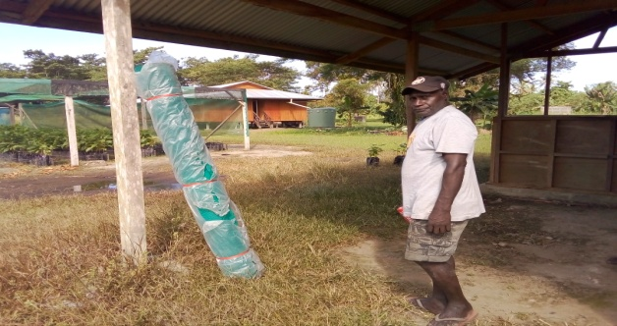

Plate 2. Model Farmer or VEW receiving his shade cloth for his nursery in the South.

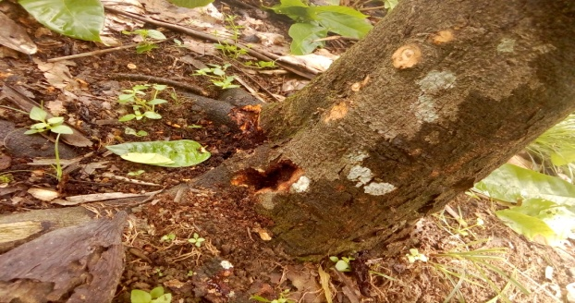

Plate 1. Longicorn attack on cocoa identified in one of the IPDM Demo blocks in the South.

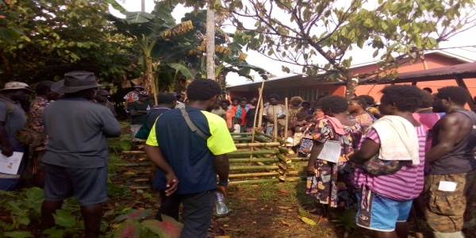

Plate 4. Cocoa Farmers and spouses taking part in the Compost making Training.

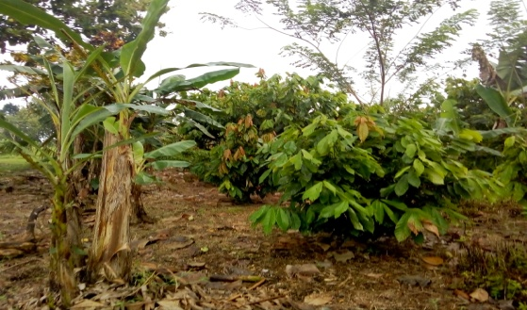

Plate 3. Photo showing the results of the IPDM trainings. This is a well-managed cocoa block of one of the recipients’ of the IPDM training.

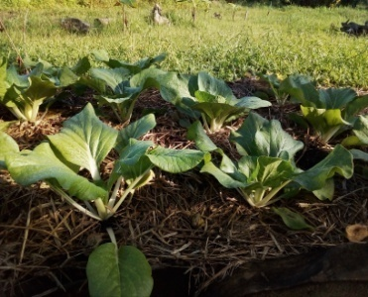

Plate 6. The cocoa pod husk compost used to grow cabbages as well.

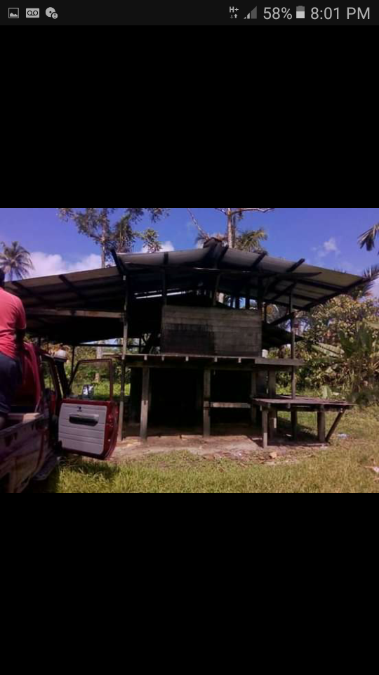

Plate 5. Conducting Cocoa quality and post-harvest awareness in the South.

**`**

**Attachment #2**

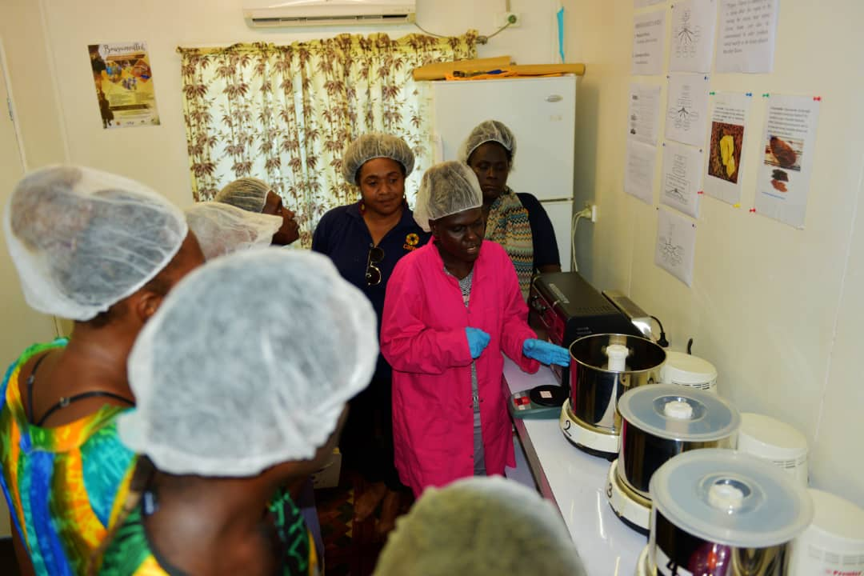

Plate 8. Chocolate Making demonstration by the North FEO Julie for women participants.



Plate 7. Demo block rehabilitation in the North of Bougainville

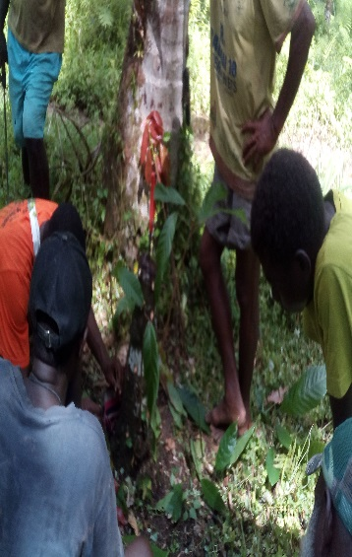

Plate 9. Chupon budding demonstrations in the North.

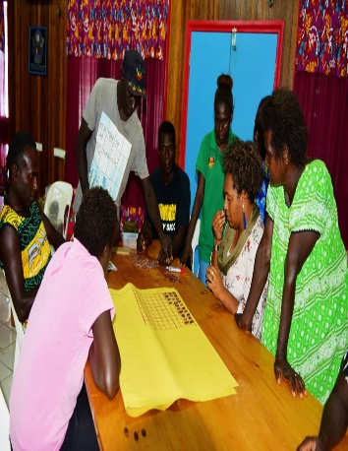Plate 9. Training on Post Harvest, and Julie taking the lead in the cut test.

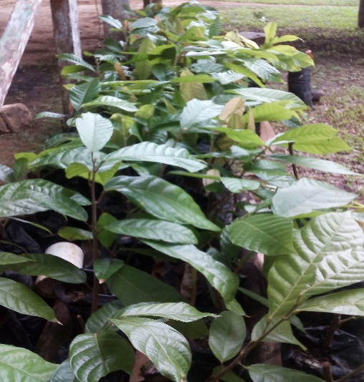

Plate 12. Result of putting what was learnt into practice. A farmer raised his own clones in a village nursery and used ice block plastic and kiwi knife to do budding.

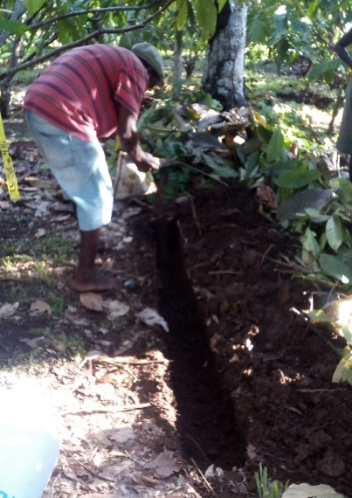

Plate 11. Trenching exercise in the demo block at siing North Bougainville

**`**

**Attachment # 3**

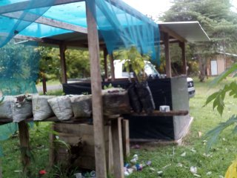

Plate 14. A compost hut at Siing, North Bougainville

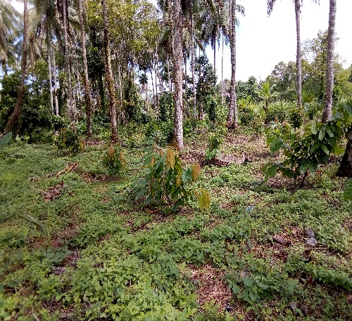

Plate 13. A well maintained budwood block almost ready for budwood harvesting.

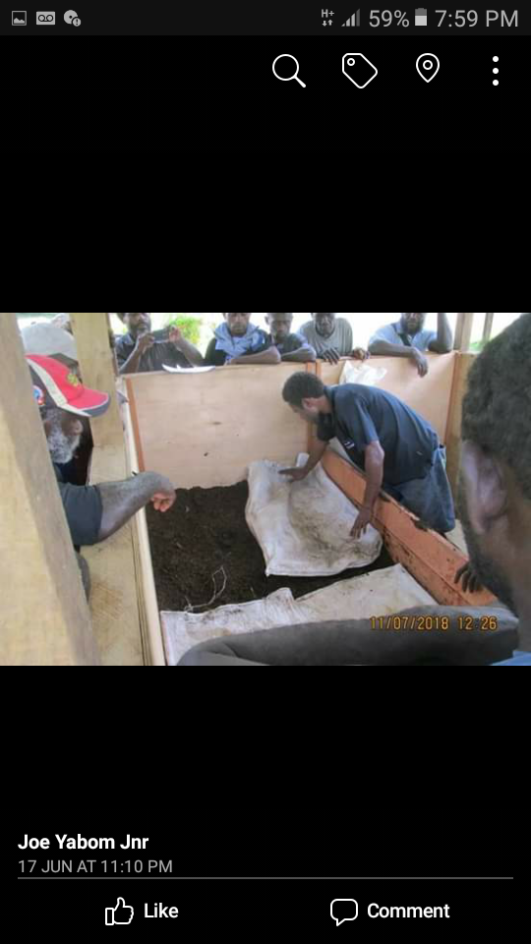

Plate 16. Cocoa Pod husk Compost making training

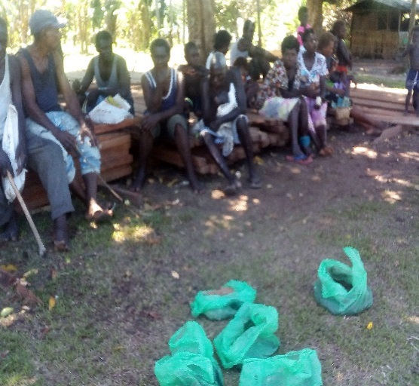

Plate 15. Compost training at ward level

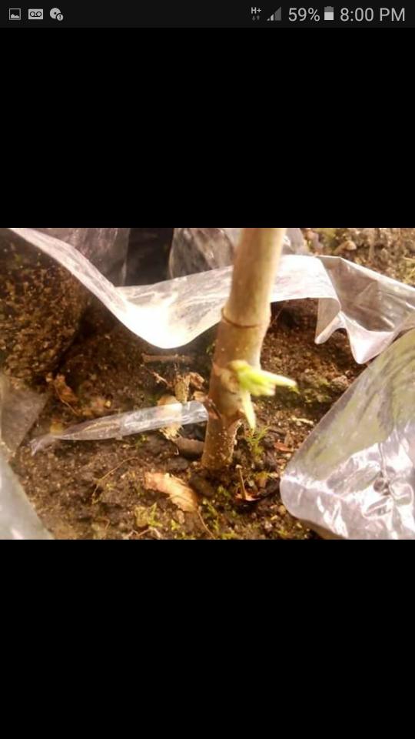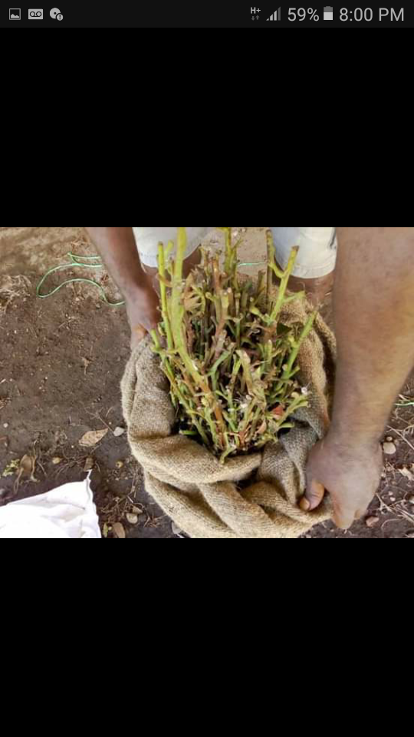

Plates 18-19. 3 weeks old clone sprouted after budding and new clones flown in from Tavilo for the new clone block for testing under Buin weather conditions.

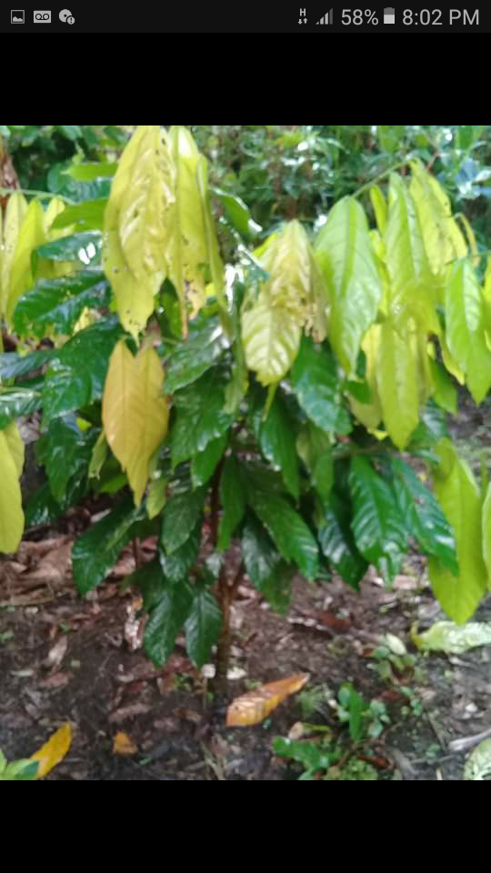

Plate 17. Hybrid Clone in the budwood gardens are ready for harvesting budsticks.

**Attachment # 4**

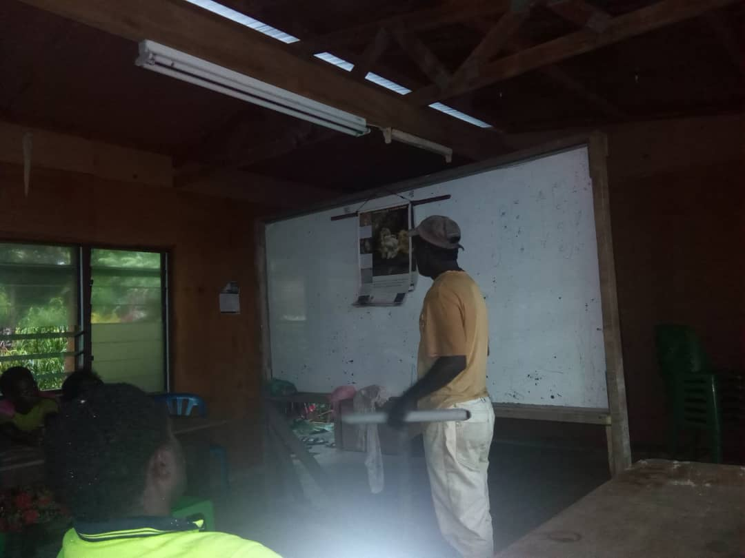

Plate 21. IPDM training conducted by the Central FEO

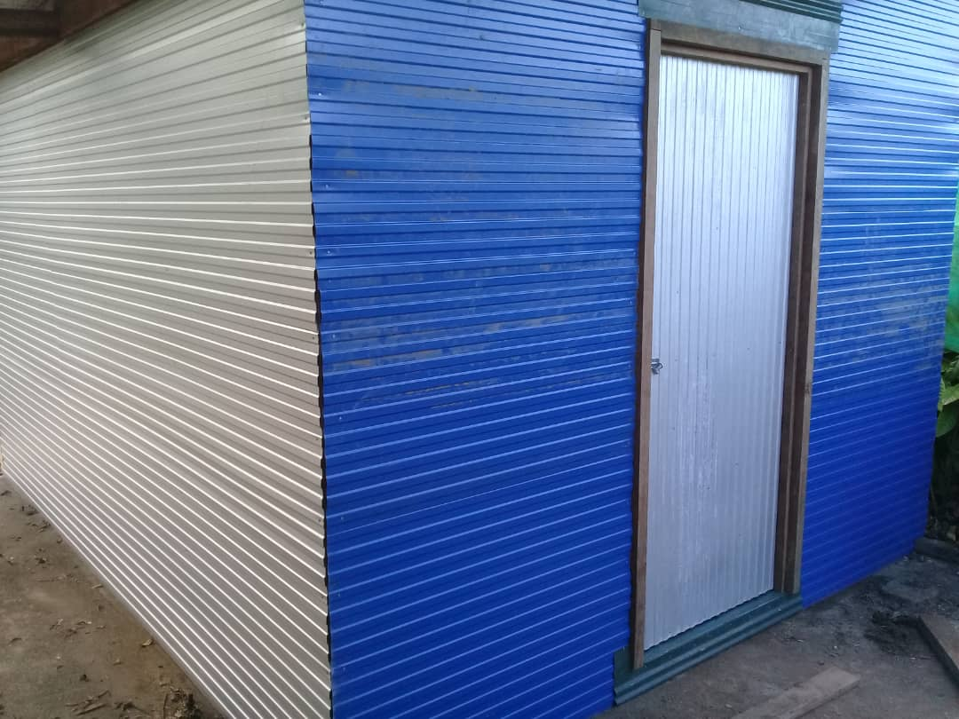

Plate 20. A storage shed built at Arawa to store all project tools and materials.

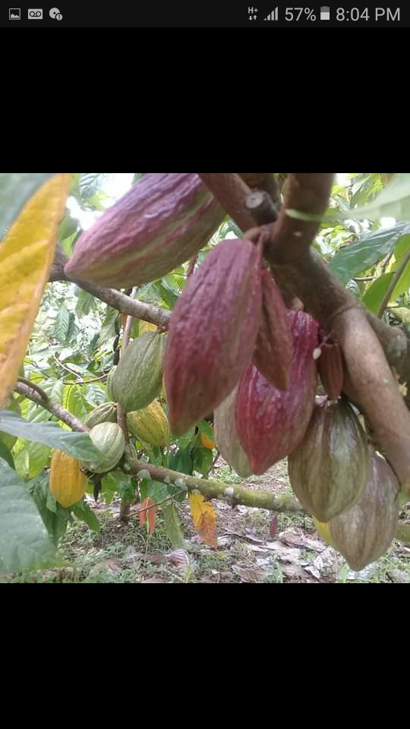Plate 23. Cocoa bearing at the Buin DPI Station’s IPDM Demo plot..

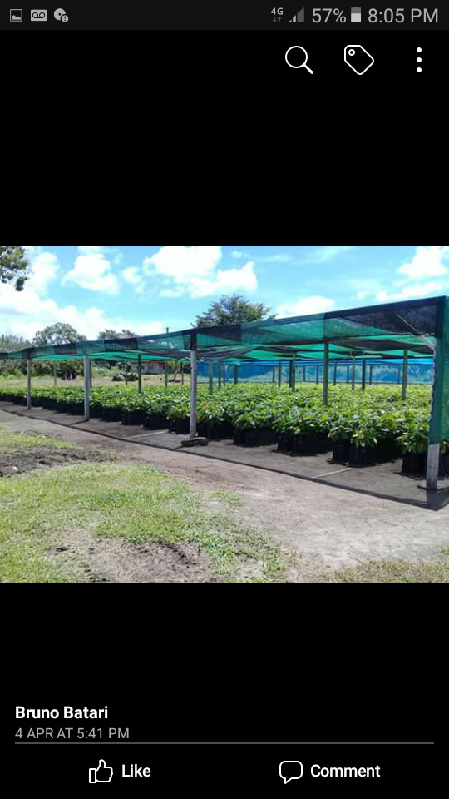Plate 22. Buin 10,000 capacity nursery. Currently have hybrid cocoa growing in the nursery in partnership with Cocoa Board’s nursery project and the South Buin District.

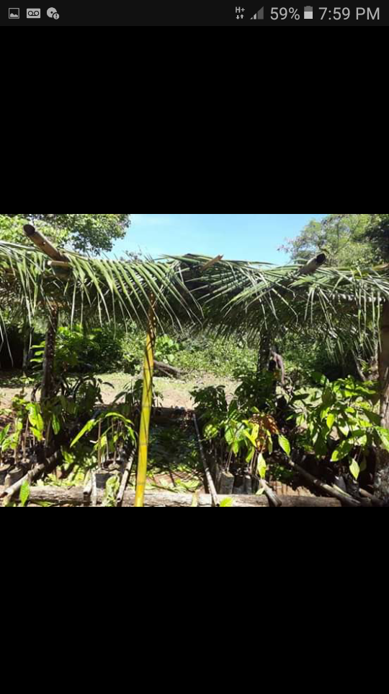

Plates 25. One of the many village nurseries built and used by a cocoa farmer to extend his cocoa block after been trained.

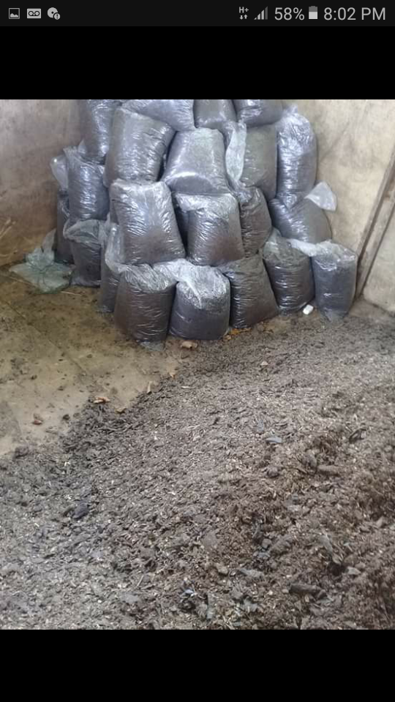

Plate 24. Compost ready for application at Central Bougainville’s compost hut.