THE BOUGAINVILLE READER

A COLLECTION OF OBSERVATIONS, REFLECTIONS AND STORIES BY PEOPLE WORKING IN BOUGAINVILLE TO IMPROVE THE LIVELIHOODS OF
COCOA FARMERS

Acknowledgements
We acknowledge and thank the tireless contributions of our project staff and casuals who have invested the time into implementing this work as well as providing data collection at Kubu. Specifically mentioned here are Raphael Tating, Bradley Nelson, Julie Rereve, Linus, Eugene Bali Hareke and most importantly all the mothers at Kubu for being son supportive. We acknowledge additional contributions from our VEWs mainly Edward Gaurom, Benjamin Tatou and farmers Cletus Suremai and Hubert while Members DPI senior Managers were so supportive especially Mrs Wendy Sawa Pihau and Kenneth Dovaro.
We thank the Australian Government for the funding through ACIAR HORT 2014 project which without it nothing would have materialized. The continuous guidance, encouragement and mentoring from the project partners and team leaders from the University of Sydney especially Professor David Guest, Dr Josephine Saul Maura, Professor Merrilyn Walton and Grant Vinning is acknowledged. This is worth noting as this initiative fosters healthy space for capacity building and inclusive article publication than the so called “Helicopter model research” in Bougainville.
Professor Merrilyn Walton

Contents

Rainfall……………………………………………………………..James Butubu
Nutrition and health…………………………………………Dr Josephine Saul
Marketing………………………………………………………..Grant Vinning

Can farmers make improvement to

their old or senile cocoa trees while

improve food security?.......................................... James Butubu

Australia funded ACIAR Project assist with Rainfall Monitoring in Bougainville

James Butubu

Rainfall is a significant climatic and environmental factor influencing crop growth and development including cocoa processing and drying. Similarly, it influences pests and disease and soil development including its physical and chemical properties that in turn affect crops. By world standards, Mawsynram (11,871mm) and Cherrapunji (11,777mm) in India have the highest rainfall in the world (Sawe, 2019, March 27). But on Bougainville we do not know where we stand in terms of world ranking or PNG ranking as a Province. Therefore, with no indicators measuring our rainfall and weather we need to introduce monitoring of rainfall as an integral part of farming. Unfortunately, most farmers in Bougainville have low capacity to collect this vital data which will provide information that would assist them to make better farming decisions as to when they should apply certain inputs. Through the ACIAR HORT 2014 project funded by Australia, rainfall monitoring commenced in Bougainville beginning with the installation of simple rain gauges in Konga DPI, South Bougainville (Figure 1) and Kubu Stations in 2019 and the initial data is presented (Figure 2). Acknowledgement to Mr Martin Tumuki (Dpi Area Manager-South Region) and his staff in Konga and ACIAR staff at Kubu for the data collection.
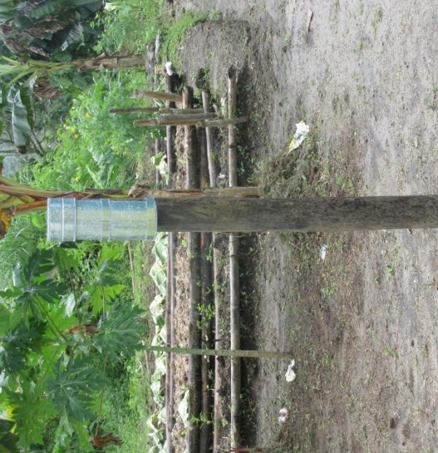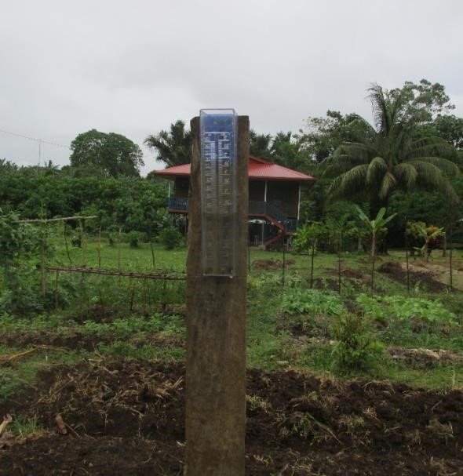

Figure 1A: Kubu

station Rain Gauge

and Figure 1B: Konga station Rain Gauge

A

B

Data Recording
Rainfall data is collected on a daily basis or occasionally after two days with monthly total volumes calculated for reporting. The amount of rainfall received each month up to December 2019 for the first time quantifies and displays the longterm unquantifiable amounts in the North (Kubu) and South region (Konga) and Bougainville as a whole. The data confirms the long-held belief that the South region is the wettest area in Bougainville (Figure2). Comparatively highest rain falls received in each region occurred in June (280mm) and September (890.4mm) with the lowest occuring in July(108mm) and October (314) respectively for Kubu and Konga. In relative terms, Kubu rainfalls are on average only 26% of the Konga rainfall volume over the corresponding months. In other words, Konga received over 70% more monthly rainfall on average for the period June-December. A linear regression model fitted indicated to the observed data strong (R² =0.6023) declining trend rainfall predictable toward December as compared to Kubu data (R2=0.3947) which shows less variation but high unpredictability on rainfall.

The data showed the two regional sites in South (Konga) recording very high rainfall compared with the North (Kubu) and perhaps most parts of Papua New Guinea. Other comparisons can be done when the rainfall data for each province is available. Approaches could be made to responsible organizations such as the PNG Weather and Meteorological services division to provide rainfall data. However, while important our immediate priorities are agricultural productivity, crop production and climate change effects within Bougainville.

Figure2
Rai
:
nfall distribution up to December
.

251.2
166.6
280
108
125
157
137
125
135
794.8
655.8
678.8
890.4
314
396
271.2
y =
-
13.777x + 233.86
R² = 0.3947
y =
-
87.686x + 1097.7
R² = 0.6023
0
200
400
600
800
1000
1200
April
May
June
July
August
September
October
November
December
RAINFALL (MM)
MONTHS 2019
Rainfall in Konga and Kubu (2019)
Kubu
Konga
Linear (Kubu)
Linear (Konga)

Rainfall and Crop production
The most common crops cultivated for cash in Bougainville is cocoa, coconut, food crop and vegetables. These crops are affected by rain fall in various ways including the varieties grown in the various localities. For cocoa the commercial varieties are the SG2, SG1 and hybrid clones and variation in production and yield is inevitable. The questions to be answered are
- How does rainfall affect flowering, cherrelles pods?
- How is the soil and sunshine availability affects production?
- What is the disease and pest pressure like during rainy periods?
- Other questions?

Research Trials establishment
The best way to answer these questions would be to conduct research trials i.e observation and Agroecological multi-location (GXE) evaluation trials as well as studies on various pests in the selected locality and collect data on different variables such as crop yields and pest & disease incidence parameters. These activities are planned for the DPI regional hubs and some Village Extension Workers sites.

Climate change monitoring
Long term monitoring of climate change through daily or regular rainfall data collection is essential to identify severe weather impacts and events and predict future events. For example, in Figure 3 (indicated by Arrow A & B) we had crop damages and water shortage in Buka- kubu, (Arrow A) in May and July and the last quarter of 2019 while in South (Arrow B) crops and infrastructure were damaged as well as delay in our monthly CRG- nutrition & vegetable cultivation program. Distribution of food rations were also given to all the population in the South region by the National Parliamentary Member for South Bougainville Honourable Timothy Masiu in October.

251.2
166.6
280
108
125
157
137
125
135
794.8
655.8
678.8
890.4
314
396
271.2
y =
-
13.777x + 233.86
R² = 0.3947
y =
-
87.686x + 1097.7
R² = 0.6023
0
200
400
600
800
1000
1200
April
May
June
July
August
September
October
November
December
RAINFALL (MM)
MONTHS 2019
Rainfall in Konga and Kubu (2019)
Kubu
Konga
Linear (Kubu)
Linear (Konga)
B

A

Figure 3: Significant effects and events associated with Rainfall that occurred in 2019.

Future Improvements
Facility improvements should include equipment to collect weather data such as humidity, temperature, wind and more. Upgrading the equipment to a digital or computerized system with data storage and sharing should be considered when upgrading the facilities. Similar facilities in other locations such as Tinputz, Wakunai, Boku (Bana), Kunua and the atolls are also required to provide Bougainville with a national picture.
Activities and Experiences in the villages and communities……before and during COVID-9

Dr Josephine Saul Maora
May 2020

Health and Nutrition Training
Staff from the Department of Primary Industries (DPI) and the Department of Health received training in health and nutrition topics that impacted on the livelihoods of cocoa farming households. This training related to the vegetable and nutrition study that focused on 10 villages most in need of support to address the high rates of stunting and malnutrition that was identified from the large livelihood survey administered in 2017.
As elsewhere in this nation, training was late starting and has been a significant issue for all our training sessions. Most people are using PNG time and not Bougainville standard time which is an hour earlier than PNG Time. Only the airlines strictly use Bougainville standard time. In Western societies time is very important and people are expected to turn up on time.
The project started with the team delivering training in nutrition and vegetable cultivation as well as conducting household interviews at Sing, Kikis and Kovanis in North Bougainville. After training in the North, the team continued south to Central region and repeated the training and interviews with villages in Wakunai. At this stage the Australian members of the team left for Buka to return to Australia leaving the local team to complete the training. I was the team leader with my team comprising Inia Bunsa from the University of National Resources and Environment (UNRE) and Bradley Nelson, a technician in the Mini Chocolate Lab, data collection, and cocoa extension trainer. We travelled to South Bougainville where we delivered training with the health and DPI staff at Lizzie’s Inn and Buin Inn. The team of DPI officers and health workers delivered training at Mosino and also completed interviews. On our return to Buin one of the rivers was flooded. The locals advised us the river was too dangerous to cross which meant we stayed over-night at the Siwai Guesthouse.
But the decision to be safe and remain overnight at the guest house was not accepted by some of the husbands of the female members of the team. I had never experienced such reluctance to be safe in the past. I work very closely with my staff members and their spouses and have never heard of this occurring before. As was experienced in the North late arrival for training was a significant factor which had an impact on the conduct of meetings and gatherings.
Apart from the displeasure of the spouses I enjoyed working with the health workers from South and learned new activities such as the proper way to wash hands. Another incident worth mentioning occurred during an interview with a particular household when one of the questions regarding the spouse did not go down well. I guessed that it must be a sensitive issue to that particular household. Body language in Family Farm Training came in handy in that situation.
One issue that arose related to some staff expecting to be paid additional money for activities outside their normal duties reflecting a hand-out mentality; this will be a barrier in future projects involving government staff and volunteers if there is not clear communication about the terms of the work. South Bougainville DPI was extremely helpful with the training activities as well as providing their vehicle to help us get around.
On the return to Central Bougainville we completed the training for the last village as well as the interviews with the assistance of the DPI officers. The health officers were unable to attend which meant the DPI officers helped us. This was a very useful experience that showed us that if the health staff are not available the DPI officers who received training can step in.
Keeping track of all the equipment and tablets was a challenge and on the last day while leaving for Buka I discovered one of the tablets was missing; this caused me a lot of worry. The last village we visited was Hohon which I attended with the DPI officers and one Health Worker. This was a great experience. The DPI officer from Kunua was present too. He was someone I knew from the Cocoa Coconut Research Institute (CCRI) days being part of the Pathology Team which I led. The Village Extension Worker (VEW) Edward kindly provided food and supplied fresh garden food to the officers from Buka. The return boat trip was uneventful up until we arrived back in Buka when we came ashore in the dark. It was a bit stressful because us 3 women were all on the one boat and there was no one to pick us for a while. The waiting time was a bit tense.
With the training component completed, the next stage of the research is to prepare the team for the monthly monitoring and mentoring visits.
Family Farm Team March 2020
PNG Air flight CG 8724 left Tokua on a beautiful Sunday afternoon around 4pm for Buka Island. It was such a beautiful flight, I guess the flight route went over the far end of the New Ireland Province and across the sea flying over Nissan Island which was so obvious because the island forms the letter “C”. It was the last flight, the plane will over-night and leave early the next morning. Robert and I were on this flight to Buka where we were met by James Butubu and taken to Lumankoa Lodge.
The next morning Eugene, the Bougainville Cocoa Value Chain Project hub manager for North Bougainville met with us. After sorting out the Family Farm Team training resources and transport, we were dropped off at Tohatsie, Kikis on Buka Island. Training started and progressed smoothly. Hand washing was done, so it can be assumed that this was from the Health and Nutrition training regarding hand washing. However, the source of the water was from a container and not running water. Michael, an elderly man of 73 was a real character especially with module 4 regarding body language. He mentioned “eyes” which in most previous trainings was not mentioned. Also my being a female trainer inspired the village women.
The boat ride to Ben Matie, Hohon in the evening was not like the calm ride of May 2019. The boat bounced around in the waves, but the team arrived safely. Seeing many canoes out fishing gave a calm feeling recalling my family informing me that they were having lots of fish for their meals. Stepping ashore, Edward was waiting, I took out my phone and saw a message regarding shut down due to the Corona virus. The team, carrying our bags walked to the hamlet where there was no reception, so the mobile phones became useless for communications at this point. Our two male colleagues were housed by Edward whilst Consolatha provided accommodation for me. I was also offered the one torch that was being used, but I refused. My hostess insisted so I had to take it. My mobile phone has a torch function, but I had to save the power for photos during training. I was provided a bed with a mattress, pillows and mosquito net with a bed-side table, the act of kindness in allowing me the use of their beddings was very highly appreciated. Consolatha also took me to the well and drew water for me to bathe. The next morning, I followed her to the nearby creek where we did laundry. I carry clothes pegs around in my bag during trips, so I pegged my clothes out to dry. I noticed that the clothesline was full of mosquito nets. I deducted from this that the village households sleep under mosquito nets, thinking that the Health Dept must have done a great job to achieve this.
The two days training went very well, at different times, I received a message from my son to call him which was a bit worrying because I couldn’t call him. When the team returned to Buka after the training at Ben Matie, a torch and batteries were purchased. In Ben Matie I borrowed a towel. In Kovanis, we experienced more kindness when we were provided a mattress, pillows and mosquito net for two nights for which I was grateful. This time I did not ask for a towel, just made do with my lap lap. By this time I was able to get reception so I called by son. I also called a few of my female friends informing them of the possibility of a lockdown due the corona virus, advising them to purchase foods that can be stored. I don’t think they believed me though. I didn’t attempt to change flights to return home because no one would believe me about the looming lockdown at that point. I enjoyed the training at this site, water was again made available in a bowl as in the other two sites –again I assumed that this was as a result of the health and nutrition training.
When training finished we set out for Central Bougainville. The damage caused by the heavy rain became obvious. I was here the month before and the roads were perfect, now the road in Tinputz looked like a bulldozer had been through the whole area. Even a huge tree had been uprooted and taken to the roadside as if for replanting. It was a slow drive to Arawa because the tyre was slit and the tube was likely to be punctured since it was exposed – talk about the devil, it was punctured. So, the very, very smooth tyre had to be put back on. At Wakunai, the punctured tyre was repaired and replaced the smooth tyre. Arrived in Arawa safely and checking into the Arawa Transit Lodge was a blessing indeed. When our team- Bruno, Theodore, Channel, myself and Robert were ready to leave for the next training site, news of the State of Emergency (SoE) reached us. This meant we had to cancel out two-day training in Central Bougainville before heading back to Buka on the 25th of March to fly out on the 26th – this became a 31 day wait. Junelyn Toura and her parents Lynette and Neil who’ve been taking care of us since the 23rd of March had been a blessing for us. The Arawa market was also shut down for over a month. Junelyn travelled to Nagovis and returned with garden food for the 1st week. Unfortunately, the rains caused flooding and Lynette’s food garden at Nagovis was washed away. Also due to the SoE, there is a road block staffed by the police at the Panguna Juction, preventing the family from going to the village. Fortunately, there are small roadside markets where Lynette purchased taro and greens (chocko tips and aibika). Arawa is a strong hold for the Seventh Day Adventists (SDA). The Toura family are SDAs, as is Robert Taula. Robert is from Mussau Island in New Ireland, but he knows many people in Arawa. There are Mussaus married to Bougainvillians and also Bougainvillians who used to be employed in Kavieng before. An interesting story about Robert was that his elder sister was married to the man from Kieta who murdered her at Aropa. Robert’s family at that time did not know where the body was laid to rest. During the lockdown, when Robert had been celebrating the Sabath he asked around abouthis sister. It was comforting to know that his sister’s body was laid to rest near Rumba SDA church ( Merrilyn, Jessica and I took a walk from Fiona’s Guest House to that Mission across the river). A person who knows where the grave is will take Robert to pay his last respect after so many years.
The lockdown in Central Bougainville, had solved a mystery in Robert Taula’s family. Robert was able to join his wantoks in Manetai who mill timber the proper way . He borrowed my ruler and drew up coffins which he shall construct when he returns to Kavieng after the lockdown. For me, I had been reviving my knitting skills I learned 36 years ago. I completed part of my bilum which needs to be connected with the other part back at Keravat. In addition, the summaries of the evaluations and surveys for FFT had been done and emailed.
On the 24th of April, a month and a day later I received a text message from Jessica that Robert and I were on Air Niugini flight Px253 the next day. There extreme time pressure, Robert rushed off to the main road, where he fortunately caught a PMV bus to Toniva where Theodore, the central hub manager was located. The tickets which Jessica email were printed. Robert successfully located Theodore and both of them drove to Arawa with Theodore suggesting they go directly to the Arawa Police Station to get a travel pass to Kokopau. However, Robert asked that they pick me up before going to the police station. As soon as I walked through the door the policemen in charge of SoE in Arawa recognized me because I went to see him earlier to register us as “stranded people”. We were not given a pass but were given a verbal green light to travel, leaving Arawa at 4am. All set, we left around 4am on the project’s open back Toyota Land cruiser. Theodore and Robert sat at the back while I sat in the cabin with Channel. No roadblocks were encountered from Arawa to Kokopau. We bid fare-well to Theodore and Channel when we reached the Buka passage. On the other side, we caught a taxi to the airport and waited until they opened. Staff at the terminal checked our temperatures using an infra-red thermometer at the gate and again at the security baggage check. We washed our hands and wore gloves size XL plus face masks and stood a meter or so apart to check in.
The plane came after a long time as well as police arriving. We passengers didn’t know what was happening but prior to boarding we had to remove the gloves, sanitize our hands and wear clean gloves, this time there were small sized gloves. We boarded the Dash 8 plane and realized that there were passengers on board. We assumed that the stranded locals attempting to return were not allowed to disembark so they had to return to Port Moresby. Robert had to spend another week or so at Keravat with his daughter and son in-law before returning to Kavieng.

Export of Papua New Guinea cocoa beans from Importers’ perspective

Grant Vinning
April 2020.

Introduction

This is an examination of the international trade of Papua New Guinea cocoa beans based on the import data from select countries.

Data

The data are provided by the United Nations’ COMTRADE system. Several points need to be made about the data base.
First, UN COMTRADE does not create any data. Instead it aggregates the data supplied by participating countries. Weaknesses with the data lie with the countries supplying the data.

Second, in the main, data supplied by importing countries tends to be more reliable than that supplied by exporting countries. This is because importing countries tend to have a higher degree of sophistication in the collecting of data. Most have EDI systems – Electronic Data Interchange. All paperwork associated with importing – such as Bill of Entry, Commercial Invoice, Bill of Lading, Import License (if needed), Insurance certificate, Letter of Credit – is usually handled electronically rather than by hand. This reduces the possibility of hand entered transcribing mistakes. Data associated with trade that travels overseas by ships is much more reliable than trade that travels across land borders by trucks.

Third, by using the one data source, there is consistency in the parameters associated with the data, namely definitions of the item being examined, method of collecting the data, timing of collection, and timing of publication. By using the one source for both import and export data allows for cross referencing. That is, one can compare what Country A says it exports to Country B with what Country B says it imports from that country.

Fourth, the table and graph below are based on the 4-digit HS code

180100 | Cocoa beans; whole or broken, raw or roasted

Countries
The import data of the following countries was examined:

Australia | Belgium | Canada | China | France | Germany
Italy | Indonesia | Japan | Malaysia | Netherlands | New Zealand
Norway | Singapore | Spain | Sweden | Switzerland | Taiwan
United Kingdom | United States.

Four of these countries do not import cocoa beans from Papua New Guinea.

Table 1. Imports of Papua New Guinea cocoa beans by select countries: 2020-2019

tonnes

Suppliers | 2010 | 2011 | 2012 | 2013 | 2014 | 2015 | 2016 | 2017 | 2018 | 2019
Australia | 51 | 35 | 99 | 56 | 63 | 46 | 100 | 56 | 79 | 108
Belgium | 6,794 | 4,181 | 4,217 | 5,009 | 3,912 | 3,910 | 4,483 | 3,524 | 3,694 | 2,910
Canada | 19 | 16 | zero | 1 | 1 | Zero | Zero | Zero | zero | 194
China | 735 | 2,175 | 120 | 1,050 | zero | Zero | 15 | Zero | 15 | zero
France | 292 | 347 | 274 | 302 | 373 | 148 | 86 | 49 | 39 | 89
Germany | 1,103 | 1,358 | 2,195 | 1,019 | 1,291 | 839 | 379 | 500 | 715 | 178
Indonesia | 8,362 | 4,440 | 3,280 | 5,250 | 5,428 | 8,587 | 4,059 | 8,191 | 3,409 | 7,408
Japan | Zero | Zero | 2 | Zero | 1 | 23 | Zero | zero | 17 | 2
Malaysia | 17,879 | 30,128 | 21,002 | 23,736 | 12,991 | 18,104 | 25,809 | 19,267 | 13,939 | 11,385
Netherlands | 578 | 200 | 21 | 139 | 41 | 35 | 7 | 55 | 105 | 943
New Zealand | 25 | 15 |  | 8 | 7 | 6 | 12 | 14 | 29 | 6
Singapore | 7,252 | 10,037 | 8,632 | 3,396 | 1,694 | 1,736 | 4,273 | 828 | 2,592 | 1,395
Switzerland | Zero | 3 | Zero | 29 | Zero | Zero | Zero | Zero | 2 | zero
Taiwan | Zero | Zero | Zero | Zero | 5 | Zero | Zero | 3 | zero | zero
United Kingdom | 1,179 | 638 | 102 | zero | Zero | Zero | zero | 8 | 5 | 5
United States | 10,574 | 7,400 | 7,793 | 6,185 | 8,819 | 10,418 | 7,147 | 9,670 | 7,667 | 4,382
Total | 54,843 | 60,973 | 47.737 | 46,180 | 34,626 | 43,852 | 46,370 | 42,165 | 32,307 | 29,005

Figure 1. Imports of Papua New Guinea cocoa beans by select countries: 2010 - 2019
COCOA BEANS. Importation from Papua New Guinea by select countries: 2010
- 2019
70000

60000

50000

40000

30000

20000

10000

0
2010 2012 2014 2016 2019

tonnes

International trade in cocoa beans: A Papua New Guinea perspective.
March 2020.
Grant Vinning

Introduction
This is an analysis of the trade in Papua New Guinea cocoa beans. It uses trade data that is becoming available for 2019. Not all countries have data for 2019 but enough is available to develop a reasonable picture.

The order of the countries covered by the analysis is alphabetically, not on their importance by either size or value to Papua New Guinea.

That countries examined are
Australia Canada France Germany Indonesia
Malaysia New Zealand Singapore United Kingdom United States

Trade data
The data are available through the United Nations’ COMTRADE system. Several points need to be made about the data base.

First, it is drawn from figures supplied by the countries. COMTRADE does not create the data. Any weaknesses with the data lie with the countries supplying the data.

Second, in the main, data supplied by importing countries tends to be more reliable than that supplied by exporting countries. This is because importing countries tend to have a higher degree of sophistication in the collecting of data. Most have EDI systems – Electronic Data Interchange. All paperwork associated with importing – such as Bill of Entry, Commercial Invoice, Bill of Lading, Import License (if needed), Insurance certificate, Letter of Credit – is usually handled electronically rather than by hand. This reduces the possibility of hand entered transcribing mistakes. Data associated with trade that travels overseas is much more reliable than trade that travels across land borders by trucks.

Third, by using the one data source, one has consistency in the parameters associated with the data: definitions of the item, method of collection, timing of collection, timing of publication. By using the one source for both import and export data allows for cross referencing. That is, one can compare what Country A says it exports to Country B with what Country B says it imports from that country.

Four, the value of exports is expressed in FOB terms whilst the value of imports is expressed in CIF terms. That is, export data is collected before the produce is shipped from the exporting country and therefore excludes all costs associated with exporting. Thus, it excludes basically shipping and insurance costs. Import values are expressed at the point of landing in the importing country so they include all shipping and insurance costs. Export and import volumes for the same item from the same exporter to the same importer can vary a little due to shrinkage or growth due to the loss of or gain from moisture.

Cocoa trade data
In common with nearly all international trade data, cocoa trade data are available in the two-, four-, and six-digit levels.

Cocoa data are available at the four digit level for the following cocoa subsectors:
- Cocoa beans, whole or broken, raw or roasted
- Cocoa shells, husks, skins and other cocoa waste
- Cocoa paste, whether or not defatted
- Cocoa butter, fat and oil
- Cocoa powder, not containing added sugar or other sweetening matter
- Chocolate and other food preparations containing cocoa

This paper reports on just cocoa bean trade in the ten countries. This is because the focus of the paper is Papua New Guinea and as far as I am aware, cocoa beans make up 100 percent of its exports of all cocoa products.
Belgium, Netherlands
Caution must be exercised when analysing the cocoa bean trade data for Belgium and the Netherlands.

Without question they are huge importers of cocoa products. They are also huge exporters of cocoa beans.

The reason for this is that the two countries’ major ports of Antwerp and Amsterdam, respectively, are amongst the busiest ports in the world. Unlike the ports that are bigger than what they are, Antwerp and Amsterdam are entrepots. That is, they export a very large percentage of what they import. They are trading posts, importing the goods in massively sized ships, then distributing them with great speed and efficiency through in a series of much smaller means that include ships, railways, and trucks.

Table 1 shows that volumes of cocoa beans imported and exported through Belgium for the period 2009 – 2018
tonnes
 | 2009 | 2010 | 2011 | 2012 | 2013 | 2014 | 2015 | 2016 | 2017 | 2081
Imports | 146,647 | 160,154 | 201,426 | 198,182 | 250,454 | 263,605 | 245,617 | 304,484 | 320,282 | 233,636
Exports | 95,594 | 82,263 | 80,663 | 114,621 | 121,086 | 135,441 | 161,187 | 187,201 | 233,088 | 189,062

Table 2 shows the same data set for the Netherlands.
tonnes
 | 2009 | 2010 | 2011 | 2012 | 2013 | 2014 | 2015 | 2016 | 2017 | 2018
Imports | 655,001 | 544,570 | 684,418 | 646,217 | 622,282 | 650,820 | 702,824 | 818,613 | 939,187 | 1,095,079
Exports | 105,400 | 111,645 | 164,249 | 141,887 | 171,585 | 197,271 | 172,048 | 138,623 | 173,397 | 161,644

Using the data I can tell you how much cocoa beans the two countries import from Papua New Guinea. Sadly, the data does not allow me to tell how much of this is exported and in what form.

The two countries are also huge exporters of processed cocoa products. In the four categories of cocoa paste, cocoa butter, cocoa powder, and chocolate, they are in the world’s top three producers.

Papua New Guinea
This is a study of the international trade of Papua New Guinea cocoa. At no stage do I use the data supplied by Papua New Guinea to the COMTRADE system.

There are two reasons for this.
ONE. According to COMTRADE, the latest two entries provided by Papua New Guinea were in 2011
and 2012. Before that the latest was
TWO. The export figures cited by COMTRADE for Papua New Guinea are beyond belief:
2012 950,827 tonnes.
2011 1,864,059 tonnes
The previous data is seven years earlier:
2004 2,159,275 tonnes
2003 1,340,622 tonnes
It is noted that I have been tracking cocoa COMTRADE data since 2010. In that time the PNG data has never been corrected

Australia

All Cocoa products

Australia imports all six forms of cocoa and cocoa value-added products. Imports in 2018 and 2019 were down on the record level in 2017. Nevertheless, in 2019 the total CIF value was US$676, 657,000.

In volume terms, in 2019 Australia imported 136,457 tonnes of cocoa and cocoa products. That is equivalent of 5.5 kgs per person.

Sadly, whilst Australia is a massive importer of all cocoa and cocoa products is a minute importer of cocoa beans.

Cocoa Beans
VOLUME

The graph is depicting the import of cocoa beans into Australia is deceptive.

To begin with, it starts at a very low base.
Next, the trend may be sharply upwards but as the table below shows, imports of beans in 2019 were slightly lower than the previous year.

In 2019, bean imports totalled just 588 tonnes.

tonnes
Suppliers | 2010 | 2011 | 2012 | 2013 | 2014 | 2015 | 2016 | 2017 | 2018 | 2019
Peru | 7 | 19 | 8 | 37 | 68 | 57 | 194 | 252 | 239 | 210
Ghana | 79 | 77 | 78 | 51 | 189 | 120 | 75 | 106 | 151 | 125
PNG | 51 | 35 | 99 | 56 | 63 | 46 | 100 | 56 | 79 | 108
Ecuador | 39 | 26 | 53 | 39 | 39 | 26 | 40 | 27 | 16 | 40
Singapore | 12 | 12 | 13 | 16 | 10 | 10 | 15 | 8 | 18 | 16
Belgium | 53 | 1 | 17 | 4 | 2 | 1 | 5 | 5 | 11 | 15
Philippines |  |  |  | 0 |  | 0 | 1 | 11 | 17 | 14
Grenada |  |  |  | 1 | 12 | 12 | 28 | 13 |  | 13
Dominica |  |  |  |  |  |  |  |  |  | 10
Peru continues to be the biggest whole bean supplier into Australia. The supply of PNG beans continues to vary quite widely.

VALUE

CIF prices for cocoa beans in Australia are discouragingly declining. The average price for 2019 was US$3,883 / tonne, over 10 percent lower than 2018’s US$4,455 / tonne.

US$ / tonne
Suppliers | 2010 | 2011 | 2012 | 2013 | 2014 | 2015 | 2016 | 2017 | 2018 | 2019
Peru | 9,571 | 2,421 | 7,125 | 5,568 | 6,426 | 6,298 | 5,072 | 5,996 | 5,456 | 4,690
Ghana | 6,975 | 7,247 | 6,346 | 5,980 | 1,550 | 4,525 | 4,213 | 3,481 | 2,901 | 2,784
PNG | 3,647 | 2,943 | 3,121 | 2,714 | 3,746 | 3,522 | 3,480 | 2,107 | 2,367 | 2,787
Singapore | 10,917 | 11,917 | 12,846 | 12,938 | 12,400 | 10,300 | 11,267 | 10,625 | 9,778 | 10,625
Ecuador | 6,462 | 6,615 | 6,472 | 5,385 | 3,923 | 4,269 | 4,275 | 3,481 | 3,813 | 2,875
Philippines |  |  |  |  |  |  | 8,000 | 6,909 | 5,941 | 5,929
Dominica |  |  |  |  |  |  |  |  |  | 6,400
Belgium | 75 | 11,000 | 5,588 | 7,250 | 8,500 | 22,000 | 8,400 | 7,200 | 6,455 | 4,067
Grenada |  |  |  | 62,000 | 5,000 | 5,083 | 2,357 | 4,692 |  | 4,462
Dominican Republic |  |  |  |  | 7,000 | 7,000 | 5,500 | 7,800 | 6,200 | 5,600

Pay no attention to the CIF prices obtained by Singapore, Philippines, and Dominican Republic. As can be seen, these are very small suppliers whose beans are being sought as a form of novelty value. Also bear in mind that these prices are CIF. This means that they include the cost of freight to Australia.

Canada
All cocoa products

Canada is a strong importer of cocoa and cocoa value-added products. Over the ten years to 2019, its imports of all five forms of cocoa increased by more than 25 percent.

Cocoa beans
VOLUME
Imports of cocoa beans into Canada have increased by more than 50 percent in the ten years to 2019. Reinforcing this strong growth has been the fact that it started from a high base: in 2010 imports were 50,662 tones.
Imports in 2019 were 91,029 tonnes.

Canada imports its beans from a very wide range of suppliers. Two things stand out about the suppliers in 2019. One is that just two suppliers – Cote d’Ivoire and Ghana – supply over 80 percent. The second is that there is a large number of small suppliers, with “small” being defined as supplying five containers or around 70 tonnes annually.
Supplier | 2010 | 2011 | 2012 | 2013 | 2014 | 2015 | 2016 | 2017 | 2018 | 2019
Côte d'Ivoire | 21,082 | 33,497 | 47,394 | 29,005 | 35,926 | 33,746 | 17,423 | 37,383 | 64,408 | 58,612
Ghana | 3,968 | 7,384 | 4,413 | 5,353 | 3,712 | No Quantity | 9,175 | 8,309 | 17,427 | 18,357
Ecuador | 248 | 1,829 | 6,201 | 12,287 | 4,484 | No Quantity | 9,737 | 8,867 | 12,850 | 6,489
Nigeria | 11,013 | 13,863 | 7,406 | 11,862 | 10,136 | No Quantity | 11,711 | 11,269 | 2,097 | 3,424
Venezuela | 1 | 1 | 4 | 6 | 157 | No Quantity | 25 | 329 | 12 | 1,407
Indonesia | 8,242 | 6,054 | 1,843 | 1,590 | 3,291 | No Quantity | 1,066 | 0 | 98 | 1,002
Dominican Republic | 1,785 | 1,622 | 1,375 | 2,200 | 1,938 | No Quantity | 1,025 | 352 | 716 | 710
Uganda |  | 27 | 41 | 471 | 200 | No Quantity | 0 | 1 |  | 217
PNG | 19 | 16 |  | 1 | 1 |  |  |  |  | 194
Papua New Guinea’s supplies can only be considered as erratic. After a seven years of zero or just one tonne, in 2019 imports jumped to 194 tonnes.
VALUE

The annual average CIF price of cocoa beans imported into Canada has declined over the decade to 2019. In 2019, the annual average was US$2,473, marginally higher compared with the previous year’s US$2,122 / tonne.

For the five years to 2014 Canada’s average CIF price was lower than the global average. Over the past four years Canada’s price has been on a par with the global average.

The CIF price of Papua New Guinea cocoa beans is the well towards the bottom end of that received by other major suppliers.
US$/tonne
Suppliers | 2010 | 2011 | 2012 | 2013 | 2014 | 2015 | 2016 | 2017 | 2018 | 2019
Côte d'Ivoire | 3,256 | 3,072 | 2,229 | 2,393 | 3,111 | 3,137 | 3,309 | 2,372 | 2,172 | 2,463
Ghana | 3,500 | 3,701 | 2,765 | 2,946 | 3,447 |  | 3,545 | 2,681 | 2,405 | 2,513
Ecuador | 3,242 | 3,065 | 1,436 | 2,358 | 3,121 |  | 3,150 | 2,292 | 2,099 | 2,480
Nigeria | 2,797 | 2,958 | 2,161 | 1,960 | 3,075 |  | 3,210 | 2,439 | 2,423 | 2,266
Venezuela | 11,000 | 2,000 | 2,250 | 4,333 | 3,248 |  | 2,640 | 2,602 | 2,583 | 2,278
Indonesia | 2,681 | 2,892 | 3,007 | 2,508 | 3,021 |  | 2,873 |  | 2,378 | 2,270
Dominican Republic | 3,090 | 2,968 | 2,345 | 2,468 | 2,914 |  | 3,214 | 2,364 | 3,003 | 3,073
Peru | 1,255 | 884 | 1,563 | 1,348 | 3,029 |  | 3,158 | 2,474 | 2,353 | 5,013
Colombia | 3,290 | 3,330 | 2,684 | 2,534 | 3,071 |  | 3,096 | 2,491 | 2,254 | 3,117
Uganda |  | 2,963 | 3,122 | 2,699 | 2,700 |  |  | 4,000 |  | 2,157
PNG | 2,368 | 3,813 |  | 3,000 | 4,000 |  |  |  |  | 2,268
USA | 3,481 | 3,406 | 980 | 551 | 3,405 |  | 4,622 | 2,863 | 2,598 | 3,059

PNG BEANS AND OTHER BEANS
There is not enough consistent time series to develop useful graphs that compare the annual average CIF price of PNG beans with the Canadian average. But there is enough to show that PNG beans compare well.
Origin | 2010 |  | 2012 |  | 2014 |  | 2016 |  | 2018
Canada | 2,958 | 3,008 | 2,201 | 2,249 | 3,108 | 3,2602 | 2,426 | 2,212 | 2,473
PNG | 2,368 | 3,813 | n.a. | 3,000 | 4,000 |  |  |  | 2,268

France

France has increased the value of all forms of cocoa imports by 15 percent in the ten years to 2019.

VOLUME
Imports of cocoa beans into France have increased steadily over the past six years. In 2019 they totalled 156,760 tonnes.

Imports are dominated by Cote d’Ivoire and Ghana who supply nearly three-quarters of all beans.
Suppliers | 2010 | 2011 | 2012 | 2013 | 2014 | 2015 | 2016 | 2017 | 2018 | 2019
Côte d'Ivoire | 53,136 | 38,116 | 31,471 | 43,216 | 42,785 | 56,765 | 63,922 | 65,912 | 74,600 | 75,048
Ghana | 48,469 | 73,784 | 70,304 | 56,808 | 66,395 | 44,976 | 54,682 | 46,837 | 47,491 | 45,233
Dominican Republic | 2,936 | 2,828 | 2,580 | 4,234 | 7,758 | 9,611 | 11,122 | 6,350 | 4,415 | 8,140
Belgium | 157 | 278 | 790 | 758 | 338 | 157 | 1,137 | 3,345 | 9,718 | 6,275
Ecuador | 3,677 | 4,224 | 3,932 | 4,575 | 5,688 | 6,269 | 6,458 | 6,928 | 4,436 | 4,756
Netherlands | 3,799 | 6,280 | 7,505 | 2,149 | 825 | 1,810 | 1,208 | 2,615 | 4,228 | 3,205
Cameroon | 891 | 277 | 96 | 1,489 | 2,633 | 4,135 | 3,450 | 1,094 | 2,149 | 3,109
Madagascar | 1,402 | 1,042 | 1,678 | 1,472 | 1,867 | 1,980 | 1,778 | 1,976 | 1,996 | 2,094
PNG | 292 | 347 | 274 | 302 | 373 | 148 | 86 | 49 | 39 | 89

France imports from around 50 suppliers. Over twenty of these are very small, less than 13 tonnes, that is one container. This shows that France is willing to experiment with different origins.
Papua New Guinea is a minor supplier, just 89 tonnes in 2019. On the other hand, it has supplied beans every year in the ten years to 2019.

VALUE

The annual average CIF price for cocoa beans imported into France has declined over the decade to 2019. In 2019, the annual average price was $2,473 / tonne.

For the past eight years France has paid over the world average CIF price.

Papua New Guinea beans are priced about the mid-range of the major suppliers: small one-off suppliers frequently secure much higher prices.
Suppliers | 2010 | 2011 | 2012 | 2013 | 2014 | 2015 | 2016 | 2017 | 2018 | 2019
Côte d'Ivoire | 3,287 | 3,057 | 2,725 | 2,629 | 3,200 | 3,300 | 3,253 | 2,669 | 2,503 | 2,530
Ghana | 3,885 | 3,512 | 3,145 | 2,816 | 3,021 | 3,459 | 3,363 | 2,782 | 2,635 | 2,558
Dominican | 3,446 | 3,713 | 3,390 | 3,583 | 3,873 | 3,517 | 2,718 | 3,210 | 3,856 | 3,445
Ecuador | 3,404 | 3,741 | 3,250 | 2,939 | 3,271 | 3,295 | 3,191 | 2,948 | 2,719 | 2,574
Cameroon | 3,173 | 3,282 | 3,042 | 2,741 | 3,225 | 3,163 | 3,295 | 2,580 | 4,072 | 3,212
Madagascar | 3,280 | 3,834 | 3,260 | 3,173 | 3,494 | 3,349 | 3,547 | 3,396 | 3,572 | 3,532
Peru | 3,992 | 4,361 | 3,432 | 3,357 | 3,994 | 3,619 | 3,650 | 3,082 | 3,925 | 3,100
Sao Tome | 3,314 | 3,311 | 3,243 | 3,092 | 3,521 | 3,701 | 3,514 | 3,441 | 3,616 | 3,669
Brazil | 5,110 | 5,659 | 5,500 | 5,474 | 3,606 | 3,304 | 2,739 | 1,833 | 3,537 | 2,811
Venezuela | 4,527 | 4,833 | 4,505 | 4,352 | 4,350 | 4,318 | 4,123 | 4,144 | 4,164 | 4,110
PNG | 3,332 | 3,504 | 3,164 | 3,182 | 3,587 | 3,770 | 3,651 | 2,510 | 3,000 | 2,652

Over the nine years to 2018, Papua New Guinea cocoa have invariably received above the average of all cocoa beans imported by France.

Germany
Germany is a strong importer of all cocoa products. Imports have increased 15 percent over the ten years to 2019. What is so encouraging about the German data is that it starts from a very high base. In 2019 the combined imports totalled nearly US$3.5 billion.

VOLUME
In the six years since the low of 244,640 tonnes in 2014, German imports of cocoa beans has nearly doubled to 469,063 tonnes in 2019.
I

Whilst Germany is a huge importer of cocoa beans and it draws it supplies from around 50 countries, the fact remains that it gets just 50 percent of the total from the one country – Cote d’Ivoire.
Suppliers | 2010 | 2011 | 2012 | 2013 | 2014 | 2015 | 2016 | 2017 | 2018 | 2019
Côte d'Ivoire | 174,548 | 249,451 | 199,864 | 172,797 | 156,856 | 208,955 | 118,926 | 135,543 | 234,293 | 252,996
Nigeria | 76,151 | 43,977 | 28,250 | 19,691 | 14,971 | 24,409 | 56,295 | 52,659 | 80,590 | 86,879
Ghana | 19,245 | 26,807 | 65,728 | 32,131 | 25,061 | 55,322 | 36,299 | 23,503 | 49,873 | 30,034
Ecuador | 14,807 | 15,220 | 19,408 | 18,827 | 16,553 | 16,697 | 15,748 | 14,490 | 14,799 | 17,733
Cameroon | 11,123 | 17,629 | 12,084 | 1,664 | 915 | 4,589 | 4,312 | 9,183 | 8,630 | 11,531
Peru | 744 | 495 | 4,426 | 7,079 | 4,907 | 9,435 | 9,681 | 8,479 | 8,715 | 9,568
Dominican R | 3,070 | 3,871 | 4,465 | 7,069 | 5,012 | 6,572 | 2,794 | 2,347 | 2,938 | 3,064
Nicaragua |  |  | 219 | 933 | 379 | 1,067 | 832 | 876 | 1,177 | 1,171
Liberia | 1,474 | 4,269 | 1,420 | 3,956 | 3,280 | 2,367 | 2,585 | 500 | 259 | 975
Guinea | 1,372 | 3,285 | 4,349 | 2,780 | 2,101 | 11,481 | 3,872 | 2,397 | 632 | 920
PNG | 1,103 | 1,358 | 2,195 | 1,019 | 1,291 | 839 | 379 | 500 | 715 | 178

Papua New Guinea is one of around 20 countries that each supplied less than 200 tonnes. As the table above shows, the supply has shrunk nearly 10-fold over the decade.
VALUE
The price that Germany pays for its cocoa beans is trending downwards over the decade to 2019. Nevertheless, the annual average CIF price in 2019 of US$2, 521 / tonne was marginally above the previous year’s $2,509 / tonne.

In the main, Germany pays the world average CIF prices, maybe even a little higher.

Papua New Guinea cocoa beans tends to receive a slightly higher price compared with the other major suppliers.
Suppliers | 2010 | 2011 | 2012 | 2013 | 2014 | 2015 | 2016 | 2017 | 2018 | 2019
Côte d'Ivoire | 3,075 | 3,108 | 2,712 | 2,754 | 3,059 | 3,019 | 3,129 | 2,552 | 2,610 | 2,555
Nigeria | 2,932 | 3,212 | 2,471 | 2,789 | 3,167 | 3,119 | 2,987 | 2,346 | 2,285 | 2,354
Ghana | 3,171 | 3,302 | 2,994 | 2,766 | 3,189 | 3,471 | 3,240 | 3,024 | 2,535 | 2,584
Ecuador | 2,953 | 3,515 | 2,848 | 2,860 | 3,213 | 3,055 | 3,082 | 2,658 | 2,613 | 2,634
Cameroon | 2,818 | 2,928 | 2,434 | 2,431 | 3,084 | 3,180 | 3,291 | 2,392 | 2,390 | 2,337
Peru | 2,945 | 3,800 | 2,593 | 2,642 | 3,299 | 3,261 | 3,277 | 2,459 | 2,533 | 2,596
Dominican R | 3,034 | 3,928 | 3,181 | 3,002 | 3,850 | 3,489 | 3,385 | 3,182 | 2,988 | 3,230
Nicaragua |  |  | 3,516 | 3,977 | 4,037 | 4,253 | 4,138 | 2,877 | 2,957 | 2,881
Liberia | 2,572 | 3,025 | 2,819 | 2,478 | 2,730 | 2,935 | 3,179 | 2,694 | 2,514 | 2,360
Guinea | 2,409 | 2,706 | 2,437 | 2,029 | 3,102 | 2,929 | 3,181 | 2,692 | 2,305 | 2,378
PNG | 3,414 | 3,432 | 3,337 | 3,204 | 3,033 | 2,993 | 2,596 | 2,614 | 2,887 | 2,955

There were just three years when Papua New Guinea annual average CIF prices were lower compared with German average. This would appear to be more a factor of the Cote d’Ivoire reigning price rather than any direct Papua New Guinea factor.

Indonesia

Indonesia has experienced massive growth in the importation of all cocoa products. Not only is the rate of increase over the ten years to 2019 seriously upwards sloping the beginning point in 2010 was very high, well over US$100,000, 000.

VOLUME

The growth of import volumes of cocoa beans into Indonesia is astonishing. In ten years they have grown from a low of 19,100 tonnes in 2012 to 239,377 tonnes in 2019.

The table below explains the changing composition of imports.

Suppliers | 2009 | 2010 | 2011 | 2012 | 2013 | 2014 | 2015 | 2016 | 2017 | 2018
Ecuador | 223 | 220 |  | 100 | 3,457 | 11,009 | 5,603 | 11,198 | 36,327 | 63,678
Malaysia | 120 |  | 378 | 2,071 | 976 | 5,232 | 2,839 | 10,500 | 55,850 | 45,106
Côte d'Ivoire | 3,407 | 6,401 | 4,214 | 5,514 | 8,241 | 60,069 | 25,169 | 6,550 | 57,359 | 38,529
Nigeria | 12 |  | 604 |  | 101 | 4,303 |  | 856 | 15,945 | 32,608
Cameroon | 1,591 | 1,989 | 3,066 | 3,892 | 2,942 | 6,356 | 6,141 | 1,815 | 29,174 | 29,770
PNG | 8,362 | 4,440 | 3,280 | 5,250 | 5,428 | 8,587 | 4,059 | 8,191 | 3,409 | 7,408
Peru |  |  |  |  | 85 | 1,972 | 1,568 | 504 | 1,660 | 6,556
Ghana | 10,875 | 7,946 | 4,301 | 3,350 | 8,250 | 9,115 | 6,200 | 1,525 | 4,177 | 6,036
Solomons | 2,400 | 3,240 | 3,133 | 750 | 1,230 | 1,005 | 1,140 | 90 |  | 1,041

Some noteworthy comments are:
- No one country provides more than 26 percent of all imports, probably the lowest such figure in the world.
- The biggest supplier – Ecuador – is not African.
- African suppliers - Cote d’Ivoire, Nigeria, Cameroons, and Ghana – provide less than half of all imports
- The big loser is Cote d’Ivoire with imports from there plunging from a high of 60,069 tonnes in 2014 to 38,529 tonnes in 2019.
- Malaysia, whose cocoa bean production in the six years to 2018 never exceeded 5,000 tonnes in any one year, supplied 45,106 tonnes.
- In 2019 Indonesia imported cocoa beans from just under 30 countries.

The figures of growth seem so astounding that there could be the temptation to blame the data on poor record keeping by Indonesia. Below is the export from the five biggest suppliers to Indonesia for just 2018.

Supplier | Indonesia import data  (tonnes) | Identified exporting countries data  (tonnes)
Ecuador | 63,678 | 58,106
Malaysia | 45,106 | 63,965
Cote d’Ivoire’ | 38,529 | 79,908
Nigeria | 32,608 | 22,917
Cameroon | 29,770 | 20,429
Total | 209,691 | 245,325

The odd thing about this examination is that based on data provided by the five exporting countries, the five exported nearly 36,000 tonnes more to Indonesia than what Indonesia claimed it received from them.

A possible explanation for the difference is that some of the grinders that in the three countries of Indonesia, Singapore, and Malaysia may have offices in the three countries. Thus there could be some confusion between which office ordered and paid for the beans and into which country were the beans finally delivered.

PAPUA NEW GUINEA
Indonesia is an important market for Papua New Guinea cocoa beans. Nevertheless imports are very erratic. Inter seasonal imports can vary by over 100 percent. Despite this, the overall trend is upwards. 2019 was a high year with imports being 7,408 tonnes.

VALUE
In the ten years to 2019, Indonesia paid a premium over world prices on three occasions.

PAPUA NEW GUINEA
Papua New Guinea beans receive just about the annual average CIF price for all Indonesia cocoa bean imports. In 2019 the annual average for PN beans was US$2,268 / tonne

Malaysia

Despite a sizeable increase over the past two years, Malaysia’s imports of all cocoa products continues to decline.

VOLUME
Malaysian imports of cocoa beans are interesting. Very interesting. For reasons I am unaware of, imports declined significantly in the period of 2012 to 2016, from a high of 339,009 tonnes to 213,841 tonnes. That is more than a third. Since 2016, imports have increased to a decade high of 351,493 tonnes in 2019. When a trend is fitted to the ten years of data, it shows a very flat line.
There are lots of things to admire about Malaysia’s imports of cocoa beans.

To begin with, whilst one country – Cote d’Ivoire – supplies around one third of all imports, Malaysia also relies on a number of other suppliers: it takes another five countries to supply an additional 50 percent.
Suppliers | 2010 | 2011 | 2012 | 2013 | 2014 | 2015 | 2016 | 2017 | 2018 | 2019
Côte d'Ivoire | 11,737 | 43,168 | 48,189 | 56,651 | 69,404 | 36,696 | 35,395 | 90,467 | 87,100 | 122,620
Ghana | 37,096 | 58,511 | 103,732 | 49,472 | 99,747 | 78,844 | 39,333 | 66,691 | 87,384 | 54,291
Cameroon | 14,022 | 9,748 | 20,751 | 14,210 | 23,183 | 16,444 | 21,031 | 33,724 | 35,040 | 42,185
Ecuador | 600 |  | 15,673 | 16,165 | 9,477 | 12,596 | 19,307 | 31,777 | 42,663 | 28,617
Indonesia | 224,192 | 153,222 | 99,395 | 120,032 | 50,913 | 28,257 | 25,871 | 24,713 | 27,333 | 27,100
Nigeria | 6,080 | 9,322 | 12,065 | 16,148 | 8,317 | 4,048 | 16,287 | 17,078 | 19,387 | 24,151
PNG | 17,879 | 30,128 | 21,002 | 23,736 | 12,991 | 18,104 | 25,809 | 19,267 | 13,939 | 11,385
Uganda |  |  | 4,945 | 5,745 | 8,420 | 9,940 | 7,091 | 10,253 | 7,029 | 9,856
Solomons | 1,277 | 1,486 | 1,138 |  |  | 3,099 | 4,787 | 4,438 | 5,010 | 3,555

Malaysia imports from around 30 suppliers. This is a relatively small number of countries compared with countries that import a somewhat comparable volume. However, Malaysia’s the size of these imports suggests several containers are involved. An interpretation of this is that Malaysia does not have a boutique chocolate- making sector.
PAPUA NEW GUINEA
Malaysia is a major destination for Papua New Guinea beans. Nevertheless, imports are extremely erratic, with inter-seasonal variations of more 50 percent being common. Sadly, the overall is markedly downwards.
In 2019, Malaysia imported 11,385 tonnes from Papua New Guinea.

VALUE
Malaysia’s average annual CIF price is a tad under the world price. This confirms that fact that Malaysia is a bulk market with little, if any, bean-to-bar manufacturers.

US$/tonne
Exporters | 2010 | 2011 | 2012 | 2013 | 2014 | 2015 | 2016 | 2017 | 2018 | 2019
Côte d'Ivoire | 3,298 | 3,012 | 2,509 | 2,524 | 3,058 | 3,011 | 3,182 | 2,197 | 2,237 | 2,325
Ghana | 3,266 | 3,339 | 2,813 | 2,457 | 3,097 | 3,211 | 3,199 | 2,332 | 2,325 | 2,404
Cameroon | 2,917 | 3,142 | 2,690 | 2,341 | 2,964 | 3,065 | 2,959 | 2,100 | 2,083 | 2,220
Indonesia | 2,959 | 2,997 | 2,474 | 2,454 | 3,066 | 2,800 | 2,893 | 2,275 | 2,676 | 2,590
Ecuador | 3,522 |  | 2,388 | 2,339 | 2,953 | 3,286 | 3,163 | 2,409 | 2,313 | 2,431
Nigeria | 3,300 | 3,002 | 2,382 | 2,470 | 3,289 | 2,960 | 2,945 | 2,195 | 2,128 | 2,270
PNG | 3,357 | 3,107 | 2,505 | 2,450 | 3,071 | 3,221 | 2,988 | 2,075 | 2,247 | 2,329
Uganda |  |  | 2,473 | 2,325 | 3,062 | 3,017 | 2,892 | 2,191 | 2,293 | 2,378
Philippines | 3,302 | 3,103 | 2,687 | 2,613 | 2,926 | 3,089 | 3,071 | 2,502 | 2,389 | 2,423
Viet Nam | 3,455 | 3,261 | 2,613 | 2,533 | 3,272 | 3,470 | 3,449 | 3,205 | 3,283 | 3,215

There are three interesting features about the prices that Malaysia pays for its imports. One is the very narrow range of prices that it pays. With the very odd exception, prices are within a few hundred dollars per tonne. The second feature is that one of the exceptions to the above comment is Vietnam. Its cocoa beans frequently receive up to US$1,000 premium. Equally importantly, this price is paid for a volume of beans that is way beyond what a bean-to-bar maker would normally require. Only once in the ten years to 2019 did the volume drop below 1,000 tonnes.
The third feature is the price that Indonesia receives. The common belief is that Indonesia produces only unfermented beans that receive a lower price compared with fermented beans. The reality is that for the three years to 2019 Indonesian beans received amongst the highest CIF prices.

The CIF price of cocoa beans imported from Papua New Guinea are lock-step with the average price that Malaysia pays for all its beans.

New Zealand

New Zealand imports of all cocoa products have remained steady over the past eight years. In 2019 the combined CIF value of all cocoa products was US$200,833,000. This is slightly down from US$208,691,000 in 2018.

n volume terms, New Zealand imports of cocoa products increased in 2019 to 44,035 tonnes from 37,916 tonnes in 2018.

On a per capita basis, this represents an average annual consumption of 9.1 kgs.

Cocoa beans
VOLUME

New Zealand imports of cocoa beans has doubled in the ten years to 2019 to 2,550 tonnes.

Nearly 95 percent of New Zealand imports of cocoa beans are from Ghana. PNG is a small and erratic supplier: in 2019 it supplied just six tonnes. It is hard to tell if the supply of 23 tonnes from Australia are re-exports from other sources.

tonnes
Suppliers | 2010 | 2011 | 2012 | 2013 | 2014 | 2015 | 2016 | 2017 | 2018 | 2019
Ghana | 948 | 1,025 | 1,518 | 1,318 | 1,473 | 2,381 | 1,702 | 1,520 | 2,203 | 2,384
Samoa |  |  | 1 |  | 5 | 27 | 9 | 37 | 21 | 39
Peru |  | 0 | 1 | 2 | 5 | 7 | 7 | 23 | 15 | 34
Australia | 0 |  |  | 0 | 1 | 0 | 1 | 1 | 2 | 23
Solomon Islands |  |  | 6 | 6 | 5 | 12 | 12 | 11 | 24 | 19
Nicaragua |  |  |  |  |  |  | 12 | 12 | 48 | 13
Dominican Republic |  |  | 1 | 1 | 2 | 4 | 6 | 7 | 5 | 11
Ecuador |  |  |  | 2 | 5 | 3 | 3 | 4 | 2 | 9
Vanuatu | 8 |  |  | 8 | 1 | 1 | 4 | 1 | 2 | 6
Papua New Guinea | 25 | 15 |  | 8 | 7 | 6 | 12 | 14 | 29 | 6

VALUE

The average annual price that New Zealand pays for its cocoa beans is declining. In 2019 it was US$2,670 / tonne, a little above the US$2,533 / tonne of 2018.

Receiving US$3,167 / tonne, Papua New Guinea cocoa beans receive a little above the average CIF price of all beans imported into New Zealand. It has to be recognised that the overall average figure is shewed downwards because of the low price but high volume of cocoa beans coming from Ghana.

US$/tonne
Suppliers | 2010 | 2011 | 2012 | 2013 | 2014 | 2015 | 2016 | 2017 | 2018 | 2019
Ghana | 3,890 | 4,324 | 3,030 | 2,751 | 2,776 | 4,226 | 3,685 | 3,139 | 2,345 | 2,521
Peru |  |  | 5,000 | 6,000 | 6,400 | 6,429 | 8,857 | 8,522 | 7,267 | 6,206
Samoa |  |  | 7,000 |  | 9,000 | 3,630 | 4,444 | 3,108 | 5,619 | 4,256
Ecuador |  |  |  | 7,500 | 11,400 | 10,667 | 11,000 | 7,250 | 8,500 | 11,222
Nicaragua |  |  |  |  |  |  | 6,000 | 6,000 | 5,979 | 6,462
Australia |  |  |  |  | 4,000 |  | 1,000 | 5,000 | 15,000 | 2,217
Dominican Republic |  |  | 3,000 | 3,000 | 3,500 | 4,000 | 4,167 | 3,857 | 4,000 | 4,273
Solomon Islands |  |  | 2,500 | 2,333 | 3,200 | 2,750 | 3,000 | 2,455 | 1,917 | 2,158
Vanuatu | 2,000 |  |  | 2,875 | 3,000 | 2,000 | 1,750 | 9,000 | 5,000 | 4,333
PNG | 3,960 | 4,267 |  | 4,125 | 3,714 | 4,667 | 3,667 | 2,786 | 3,138 | 3,167

Singapore

Singapore’s imports of all cocoa products show a strong year-to-year variation. The result is that over the ten years to 2019, the overall growth has been quite flat.

VOLUME
Imports of cocoa beans into Singapore follow the pattern of all cocoa-products. That is, a degree of inter year variation resulting in a flat trend over the 10 years to 2019.

Imports in 2019 were 90,797 tonnes.

The importing of cocoa beans into Singapore shows some interesting features.

Suppliers | 2010 | 2011 | 2012 | 2013 | 2014 | 2015 | 2016 | 2017 | 2018 | 2019
Ghana | 7,101 | 15,712 | 29,818 | 27,999 | 37,340 | 30,922 | 28,798 | 46,305 | 46,945 | 44,716
Indonesia | 54,015 | 36,574 | 40,327 | 40,830 | 29,219 | 21,943 | 22,324 | 13,876 | 19,008 | 18,291
Cameroon |  |  | 100 | 2,389 | 8,547 | 10,682 | 10,141 | 8,898 | 8,612 | 14,836
Uganda |  |  |  | 280 | 1,620 | 5,200 | 4,327 | 6,118 | 4,975 | 3,951
Côte d'Ivoire | 7,637 | 4,453 | 2,485 | 1,170 | 886 | 3,318 | 3,147 | 910 | 2,012 | 1,919
Philippines |  |  |  | 30 | 15 |  | 766 | 1,596 | 1,184 | 1,497
PNG | 7,252 | 10,037 | 8,632 | 3,396 | 1,694 | 1,736 | 4,273 | 828 | 2,592 | 1,395
Peru | 965 | 400 | 300 | 250 | 567 | 202 | 192 | 0 | 503 | 940
Vanuatu | 650 | 173 | 213 | 105 |  |  | 186 | 703 | 120 | 591
Solomons | 766 | 1,048 | 300 | 51 | 100 | 30 | 75 | 885 | 632 | 405

One country – Ghana – provides nearly half of all imports. The three largest suppliers make up nearly 85 percent of the total. Singapore is one of the few importers that purchases a high percentage of its supplies from either Ghana or Cote d’Ivoire and not a sizeable volume from the other.

In 2019 Singapore imported beans from around 20 suppliers. This shows that its grinders are willing to experiment with different sources.

PAPUA NEW GUINEA
Singapore used to be a major importer of cocoa beans from Papua New Guinea. Note ”used to be”. Not any longer. Instead, it is fast disappearing as a source. In the ten years to 2019, supplies have gone from a high of 10,037 tonnes in 2016 to a low of just 828 tonnse in 2017. Whilst there has been some recovery from this low, in 2019 imports from there were still only 1,395 tonnes.

VALUE
The annual average CIF price that Singapore pays for its cocoa beans is declining in a somewhat alarming manner.

Singapore tends to pay a little below world prices for its beans.

US$ /tonne
Exporters | 2010 | 2011 | 2012 | 2013 | 2014 | 2015 | 2016 | 2017 | 2018 | 2019
Ghana | 3,951 | 3,190 | 2,771 | 2,691 | 3,363 | 3,268 | 3,218 | 2,178 | 2,403 | 2,393
Indonesia | 2,866 | 2,896 | 2,370 | 2,365 | 3,289 | 3,199 | 3,037 | 2,135 | 2,391 | 2,390
Cameroon |  |  | 2,390 | 2,530 | 3,258 | 3,225 | 3,071 | 2,132 | 2,287 | 2,342
Côte d'Ivoire | 3,459 | 3,293 | 2,837 | 2,319 | 3,011 | 3,438 | 3,109 | 2,103 | 2,449 | 2,317
Philippines |  |  |  | 2,167 | 2,867 |  | 3,134 | 2,187 | 2,148 | 2,411
PNG | 3,266 | 3,038 | 2,577 | 2,224 | 3,208 | 3,305 | 2,875 | 2,017 | 2,139 | 2,393
Peru | 3,763 | 1,670 | 2,340 | 2,532 | 3,198 | 3,045 | 3,146 |  | 2,284 | 2,556
Vanuatu | 3,569 | 3,029 | 2,446 | 2,343 |  |  | 2,919 | 2,176 | 2,225 | 2,291
Solomons | 3,012 | 3,028 | 2,163 | 3,020 | 3,210 | 3,400 | 2,787 | 2,072 | 2,233 | 2,338

Papua New Guinea cocoa beans receive just a little below the annual average CIF price for all beans imported into Singapore.

For 2019, the annual average CIF price paid for PNG cocoa beans was US$2,393 / tonne.

United Kingdom
Imports of all cocoa and cocoa products into the United Kingdom have grown over the ten years to 2019. Maybe the growth has not consistently year-on-year but certainly the trend has been upwards.

VOLUME

Imports of cocoa beans into the United Kingdom are declining. Whilst there has been an encouraging rebound over the past three years, it was preceded by five years of decline. So it remains to be seen if the recent upward movement will be sustained.

In 2019, the United Kingdom imported 101,353 tonnes.

The United Kingdom imports cocoa beans from around 30 countries. Just on half comes from Cote d’Ivoire. What is odd is that France supplies 35,736 tonnes. The top three suppliers provide just under 95 percent of all imports. About a third of all suppliers provide less than a container annually.

Suppliers | 2010 | 2011 | 2012 | 2013 | 2014 | 2015 | 2016 | 2017 | 2018 | 2019
Côte d'Ivoire | 21,490 | 26,562 | 34,392 | 41,897 | 34,386 | 39,266 | 30,559 | 57,890 | 47,750 | 51,467
France | 3,005 | 3,504 | 2 | 6 | 8 | 10 | 20 | 32,885 | 39,029 | 35,736
Ghana | 92,065 | 100,436 | 51,522 | 25,350 | 25,000 | 18,006 | 1,170 | 11,673 | 24,852 | 9,384
Peru | 36 | 33 | 61 | 84 | 121 | 186 | 145 | 240 | 215 | 258
Singapore |  |  | 0 | 0 |  | 1 |  | 1 | 0 | 225
Belgium | 166 | 35 | 103 | 54 | 516 | 33 | 30 | 60 | 256 | 45
Ecuador | 727 | 3 | 308 | 113 | 44 | 29 | 86 | 2 | 15 | 33
Colombia |  | 90 | 75 | 6 | 0 | 20 | 30 | 16 | 16 | 26
Cuba |  |  |  | 25 | 25 | 38 |  |  |  | 25
PNG | 1,179 | 638 | 102 |  |  |  |  | 8 | 5 | 5

Imports from Papua New Guinea have plummeted in the ten years from 1,179 tonnes in 2010 to just five tonnes in 2019.

VALUE

The price that the United Kingdom pays for its cocoa beans is around the world average.

The data suggests that Papua New Guinea receives a good price for its cocoa beans. However, the volumes are so small and erratic that one must be very cautious about drawing too strong a conclusion.
US$ / tonne
Suppliers | 2010 | 2011 | 2012 | 2013 | 2014 | 2015 | 2016 | 2017 | 2018 | 2019
Côte d'Ivoire | 3,181 | 3,049 | 2,562 | 2,789 | 2,938 | 2,897 | 3,220 | 1,836 | 2,287 | 2,399
France | 3,761 | 3,447 | 27,000 | 9,833 | 10,250 | 8,700 | 5,650 | 2,742 | 2,329 | 2,498
Ghana | 3,454 | 3,504 | 3,379 | 3,174 | 2,968 | 2,447 | 3,549 | 2,524 | 2,383 | 2,540
Peru | 6,528 | 7,212 | 7,082 | 6,238 | 6,479 | 5,672 | 6,607 | 6,725 | 6,116 | 5,174
Ecuador | 3,292 | 5,667 | 2,334 | 2,832 | 5,500 | 6,414 | 3,140 | 9,000 | 5,800 | 4,788
Colombia |  | 5,589 | 3,533 | 4,167 |  | 4,650 | 6,000 | 6,813 | 6,250 | 5,923
Cuba |  |  |  | 3,680 | 3,440 | 3,763 |  |  |  | 2,960
Venezuela | 4,042 | 4,370 | 4,111 | 3,800 | 4,429 | 4,500 | 4,240 | 4,293 | 6,194 | 2,840
USA |  |  |  | 9,000 | 13,000 | 5,800 | 9,455 | 16,750 | 10,000 | 24,000
PNG | 3,505 | 3,533 | 3,196 |  |  |  |  | 3,375 | 4,000 | 4,400

United States

Not only is the United States the biggest importer of all cocoa and chocolate products in the world, its imports are increasing. Indeed: God Bless America.

VOLUME

Whilst the United States imports of all cocoa products is trending upwards, its imports of cocoa beans is trending downwards. Not only that, its imports have been erratic. Over the ten years to 2019, the record is one of an increase in one year followed by a decrease the next. To make matters worse, imports of 375,538 tonnes was not only the lowest in the decade to 2019, it was the second consecutive year that imports declined.
The table below shows a number of interesting feature about cocoa bean imports into the United States.
tonnes
Suppliers | 2010 | 2011 | 2012 | 2013 | 2014 | 2015 | 2016 | 2017 | 2018 | 2019
Côte d'Ivoire | 175,151 | 247,328 | 247,251 | 271,094 | 248,650 | 268,221 | 273,479 | 297,269 | 269,285 | 208,246
Ghana | 29,272 | 67,525 | 47,061 | 60,411 | 56,216 | 63,078 | 57,809 | 64,747 | 51,391 | 71,352
Ecuador | 29,075 | 77,145 | 52,117 | 66,467 | 78,558 | 98,512 | 55,596 | 56,021 | 50,532 | 46,657
Dominican R | 17,312 | 16,076 | 30,913 | 21,255 | 22,374 | 25,573 | 16,547 | 17,570 | 17,833 | 25,617
Peru | 721 | 2,343 | 1,040 | 3,177 | 2,561 | 2,123 | 3,109 | 4,951 | 3,794 | 5,150
PNG | 10,574 | 7,400 | 7,793 | 6,185 | 8,819 | 10,418 | 7,147 | 9,670 | 7,667 | 4,382
Nigeria | 7,161 | 16,251 | 16,188 | 6,500 | 14,650 | 2,036 | 1,805 | 13,068 | 7,222 | 3,623
Haiti | 1,541 | 2,540 | 4,157 | 1,004 | 2,059 | 1,254 | 420 | 1,166 | 1,011 | 2,145
Venezuela | 884 | 174 | 175 | 1,098 | 733 | 2,876 | 239 | 1,149 | 2,291 | 1,846
Madagascar | 266 | 768 | 1,178 | 1,387 | 675 | 1,106 | 707 | 1,149 | 798 | 1,019

At one end, importers are highly concentrated. One country – Cote d’Ivoire – supplies just over half of all imports. Nearly all the decline in imports between 2019 and 2018 can be attributed to the decline in imports from Cote d’Ivoire. Four countries – Cote d‘Ivoire, Ghana, Ecuador, Dominican Republic – provide just under 95 percent of imports.
At the other end of the volume scale, the United States does not have a great history of experimentation with new suppliers. It imported beans from less than 40 suppliers. Unlike many countries examined in this study, there are not many countries supply well less than a container.
PAPUA NEW GUINEA

Imports of cocoa beans from Papua New Guinea, whilst sizeable, are trending downwards. In 2019 they were 4,382 tonnes. Like overall imports, this was the lowest volume in ten years and was the second year in a row that they declined.
VALUE
Given its importance as the world’s largest single importer of cocoa beans, it follows that there is little difference between average world CIF price and that of the United States.

Over the ten years to 2019, Papua New Guinea cocoa beans received a small but consistent premium over the annual average CIF price of all beans imported into the Unites States.
In 2019 this US$2,595 / tonne

Can farmers make improvement to their old or senile cocoa trees while improve food security?

James Butubu

Back ground Information

The issue of senility of cocoa trees (low yields) and rehabilitation.
Despite of the change and improvement of planting materials from Trinitario to the release of Improved hybrids varieties (SG1 & SG2) and then the release of the best hybrid clones recently, there had being very little or slow progress made in terms of increasing the PNG’s production over and above the 50,000 tonne mark. There are many complex factors that can be identified ranging from economics, socio economics including poor health, political, cultural and low tree productivity factors broadly just to name a few. Low productivity is understood to be partly associated with the senility of the old plantings of hybrid materials (SG1 & SG2) and hybrid clones that were distributed in the 1980s and early 1990s. However, the issue of low productivity scenario is not only restricted to PNG but also experienced worldwide in cocoa growing areas and can be addressed accordingly with new technologies, good health and nutrition and may be with good agriculture practices. According to Ogunlade et al apart from the soils carrying these old plantations are been depleted in major nutrients, the sustainable option to enhance productivity on these old and soil nutrient depleted farms is to rehabilitate the old cocoa trees and ameliorate the soil (Ogunlade et al., 2017).
The concept of rehabilitation is being interpreted differently by different experts and this variation in views also depends on a specific situation, location and may be also difference in seasons (timing). My view of rehabilitation is in line with Sherperd (1955), who considered rehabilitation to be the restoration of yields to their peak level or at least closer to its peak levels by systematic replacement of inferior trees through grafting, and replanting techniques. Experimental trials in PNGCCIL with the IPDM (Integrated Pest and disease Management) development technology ( Konam et al., 2008) as well as hybrid clones rejuvenation trials from the Plant breeding sub-program of PNGCCI (unpublished) have shown that high yields can be restored by rehabilitation of senile trees. This was also recently demonstrated by Kouame et al., 2016) in old senile cocoa farms in Cote ‘D’ ivoire, West Africa. This is in contrast to Wood and Lass (1985) who considered rehabilitation to be the process of restoring yields by improved cultivation and management of existing mature cocoa trees. This as we understand today is part of the good farming practice (GAP) or good husbandry practices and is still valid today.
The current released cocoa hybrid clones’ yield in PNG conditions reaches their peak level of 2500 kg dry bean /ha to 3000kg dry bean/Ha at around five (5) to six (6) after initial production and declines thereafter. This is so because cocoa in PNG comes into production as early as 18 months (1.5 years) to 24 months (2 years) due to the fertile and volcanic soils. Other experience (Montgomery, 1981) in West Africa shows that highest cocoa yields are achieved between 15 and 25 years after which the yields will start to decline. These variations probably depends on the soil types, weather patterns and the genetic materials used (Genotype x Environment effect). PNG’s production system is based on the Trinitario X Amazonia hybrids (SG1 & SG2) or hybrid clones (Efron et al., 1996) and the Trinitario as in the earlier days of the cocoa industry in PNG as reported above.
The problem of low productivity associated with old age of trees (Senility) as well as early yield decline (4-5 years after planting) in the cocoa genetic materials in PNG is a serious problem that can be investigated and correct measures put in place if and when resources are made available. This will therefore greatly assist in the increase of the overall yield from the current levels in the future if farmers adopt and implement the techniques. One important issue or constraining factor is been that although there are technologies available there has been low extension and trainings conducted in strategic locations especially in Bougainville. Therefore, we are slowly initiating this rehabilitation activity as a model and for observations on rehabilitation of both senile hybrids and released clone trees with the following purpose or objectives
- To conduct awareness, demonstrations and training on rehabilitation techniques and replanting cycles for farmers to adopt rehabilitation or the IPDM technology

- To conduct basic research and/or observations into systematic rehabilitation methods with integrated food crop farming systems for food security, family health & nutritional and income diversification purposes

- Materials and Methods
1.1 Selection of senile cocoa blocks.
Old cocoa Blocks were selected according to the age of the trees which ranged from 15-20+ years for hybrid clones (Figure 1) and SG1 or SG2 hybrids. The rehabilitation techniques applied to each of planting materials types were completely different as they also have differing tree statures. Trees were pruned heavily to approximately 90-100% canopy removal such that new regrowth is encouraged on the primary and secondary branches, plagiotropically and orthotropically from the main trunk and base of the trees. Selective pruning was done after 3-4 months to remove unwanted branches (Figure 2) to form and structure the tree’s new canopy in a right formation (Figure 3).
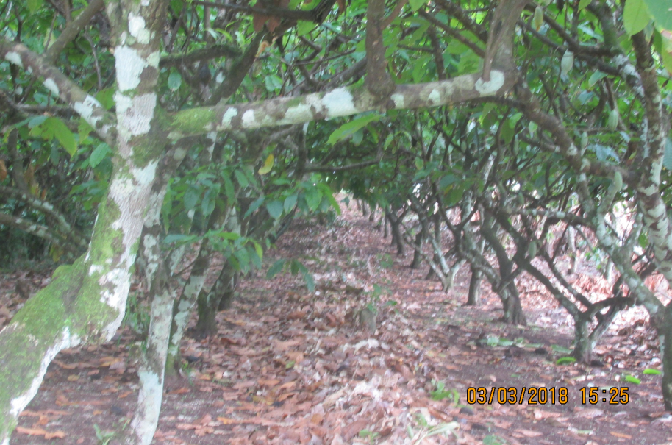
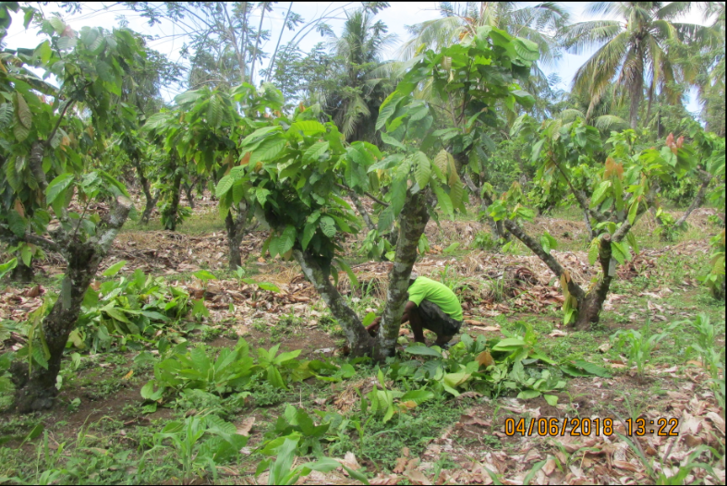
Figure 1. Before rehabilitation-Kubu hybrid clones ( 25 years old)

Figure 2: 3-4 months after heavy pruning- Selective removal of chupons for new canopy formation

  - Tree maintenance:
1.2.1 Hybrid clones:
The clone trees were maintained through regular light pruning as the new growth of branches were still young while good husbandry was practiced such as block sanitation, formation pruning and weed control manually such as slashing and stripe weeding. The trees were unshaded as the old glidicidea shade trees were removed so that a lot of sunlight is available which is sometime more than adequate especially whenever there are occasional dry periods. Despite this cocoa leaves at the top of the branch tips were still green and healthy without sun scotching (sunlight damage) that would be normally expected. Flowering from the new branches and the tree trunk started as early as 6 months so that they mature 5-6 months later or 12-13 months after rehabilitation through heavy pruning (Figure 4).
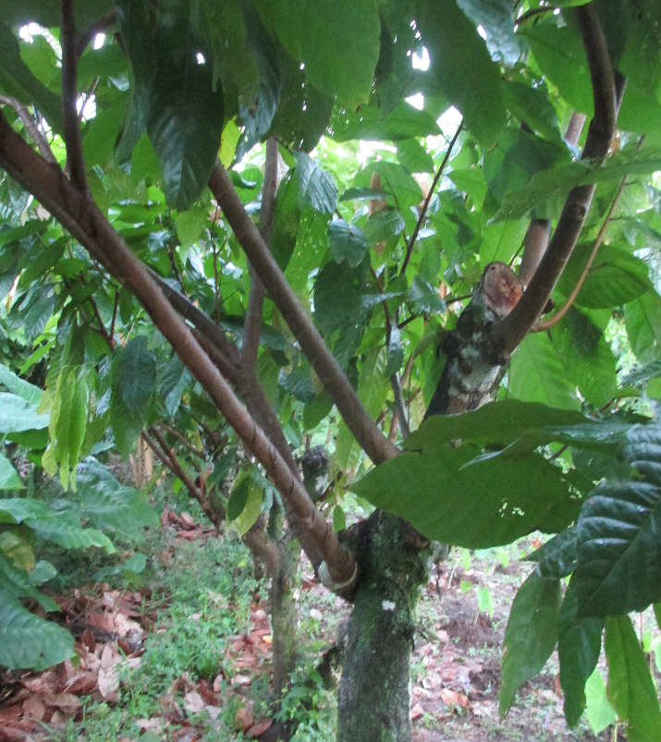
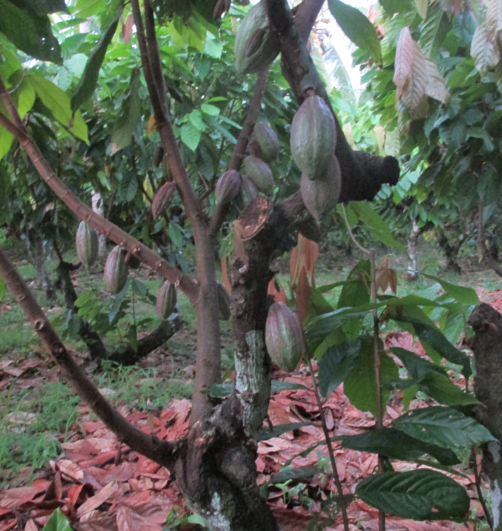
Figure 4. 12-14 months after rehabilitation and trees are fully restored and pod harvesting initiated
Figure 3. Rejuvenated trees-13months later have new healthy branches and trees are formed

1.2.2 Hybrid tree rehabilitation
Hybrid seedlings distributed to farmers in PNG are the SG2 hybrids while the earlier plantings were the SG1 and the open pollinated seeds of Trinitario (German Kakao) trees. Some of these trees that were planted in the 1980s and by 2019 they are well over 30 years old. After heavy pruning was done in end of July 2019, restructuring of canopy (Figure7A&7B), chupon grafting and field budding with new productive clone (Figure 8A) were conducted in November 2019 to assess the effect of rehabilitation.
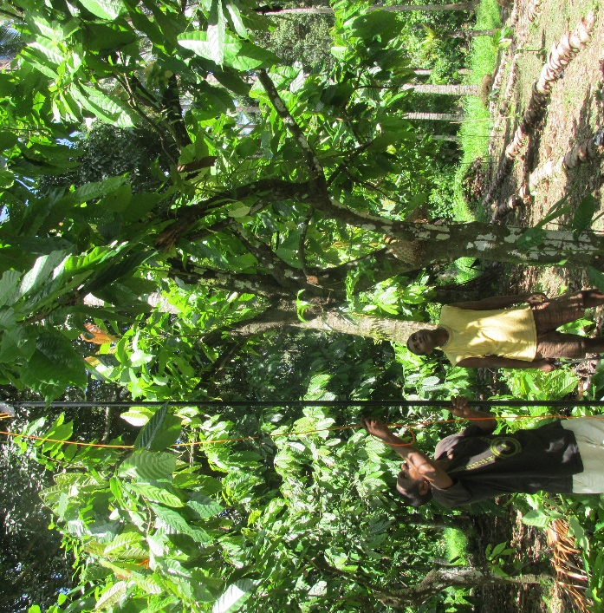
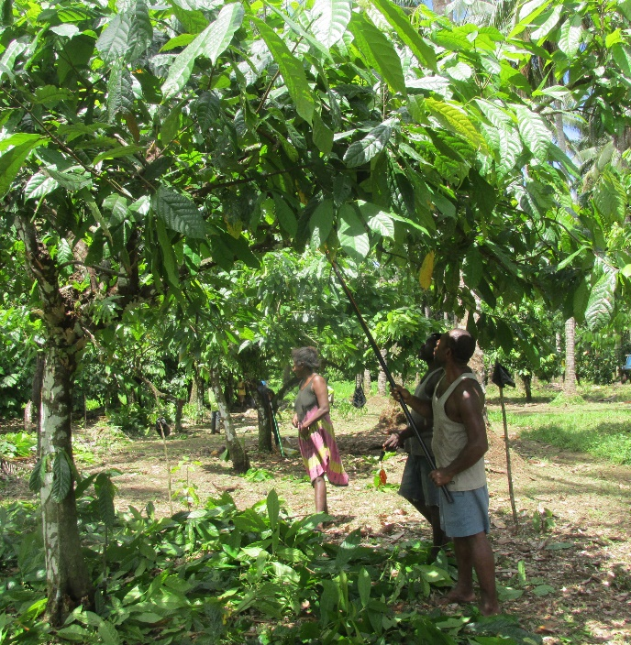
Figure 5A & 5B: Training on restructuring and formation pruning 4 months after heavy pruning of 34 years hybrid trees
A
B
Figure 6A: Training of farmers on Chupon grafting on old trees, 6B) Filed grafting of rootstocks planted to replace dead trees
A
B
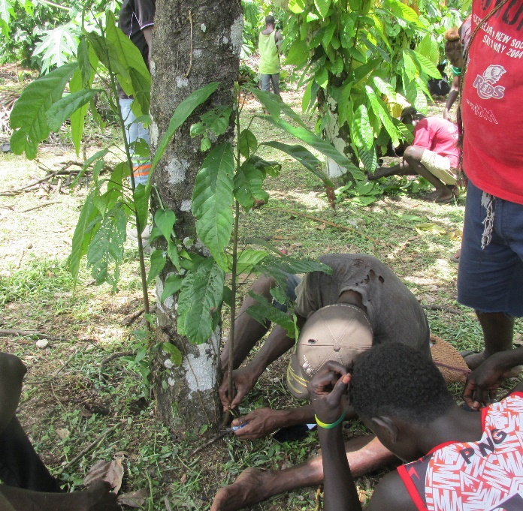
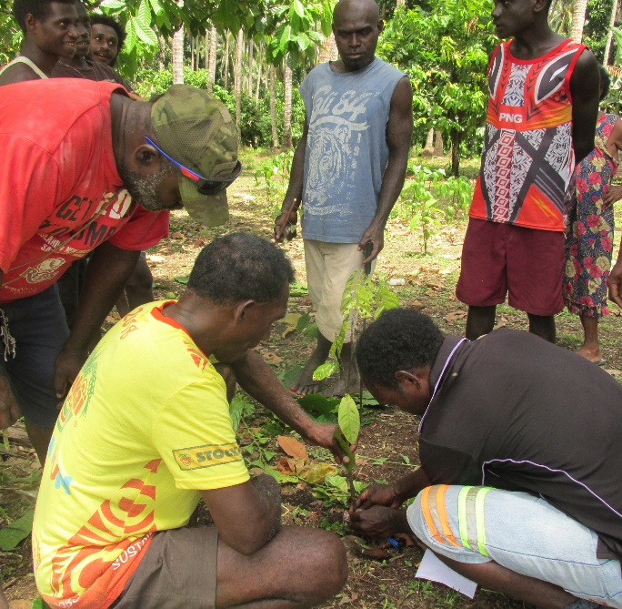

1.3 Data Collection
1.3.1 Pod harvest: Ripe pods were harvested fortnightly/monthly and recorded for each of the trees for each clones per row. Number of mature pods and cherelles were counted and recorded in addition to the ripe pods and later converted to equivalent ripe using finding of Efron et al.,2003 .on pollination efficiency and yield efficiency of SG2 hybrid varieties.

1.3.2 Mean Pod weights: Total number of pods harvested from each clone trees were put into plastic bags weighed using a scale and the mean pod weight per clone calculated as: Total pods weight/Total number of pods
1.3.3. % wet bean: This is the bean content excluding the pod husk weighed separately and dividing that wet bean weight by the total pod weight multiplying by 100%.
1.3.4.Dry Bean Yield: Pod yield per tree was estimated using the mean total number of ripe pods /tree for each clone, mean pod weight(kg) for each clone, the % pod bean and % conversion factor (40%) from wet to dry bean and multiplying by the planting density of 833 trees/ha.
1.3.5 Canker assessment: The canker was assessed rated on a scale of 1- 6 where 1=total absence of canker incidence and 6=dead of tree from canker plus other pest (termite, root rot) associate infection. The black pod was assessed through regular pod harvesting of ripe and diseased pods for each tree in a row or plot.

- Results & Discussions
2.1 Effect of rehabilitation on yield
Yield (dry bean/ha) for the 26 years old Small cocoa clones in Kubu. The progressive cumulative high yield of released clones 17-3/1, 34-13/2, 73-14/1 and 63-7/3 as well as provisionally released clone 17-7/4 is still maintained (Table 1) showing their high yielding potential than the non-released clones 24-7/1, 24-4/4. 23-6/1, and 17-7/4. Their yield ranking shows that 17-3/1(100%) was the highest yielding (Figure 5A) after 12 and 18 months of rejuvenation followed closely by 63-7/3 (96.7%) and 34-13/2(90.3%) with their respective yields of 2511, 2429,2268 and 1754kg dry bean/Ha. On average % yield change from 12 months to 18 months was 52.8% showing a progressive improvement in production. The highest yield change above 50% were from a the clone 34-13/2 (64%), 24-7/1(62.5%) ,23-6/1(61.6%),63-7/3 (57%),73-14/1(53.7%)
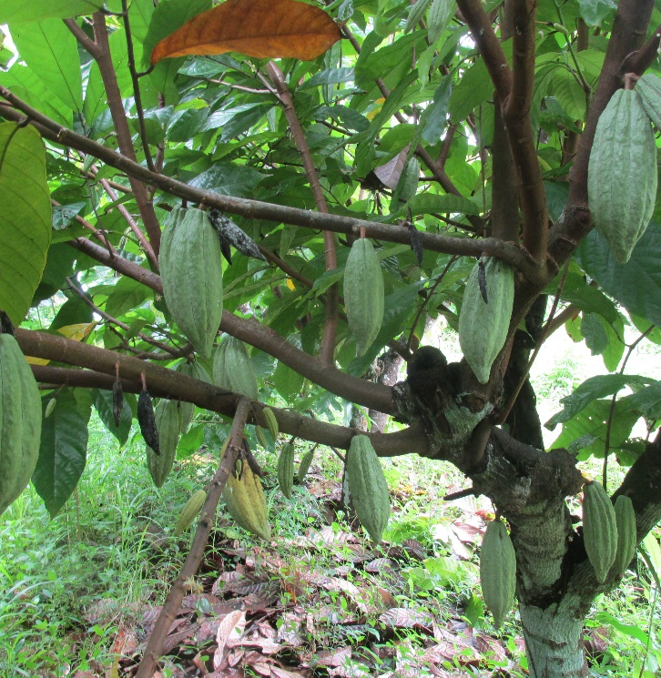
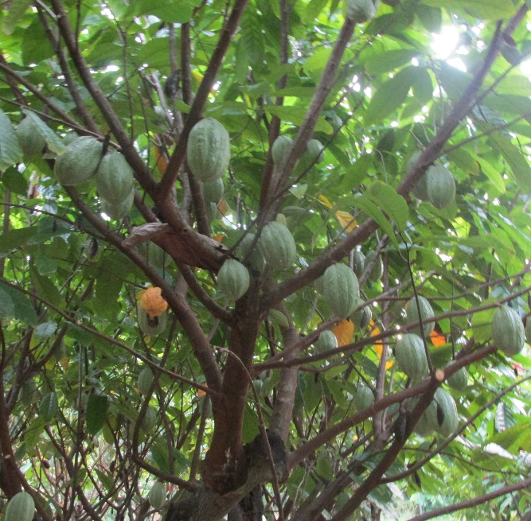
Figure 7A: 17-3/1 a productive clone with pods on low branches and the main trunk
Figure 7B :Pod Production of clone 34-13/2 which showed highest yield change in 18 months
While

Table 1: No. trees, Means of pods/tree and Yield components, Total pod no. progressive yields in 12 and 18 months, Relative yields and yield change(%) after rehabilitation
1st Series Small Clones | Commercially  Released  by PNGCCI | No .trees/Row  per clone | Mean ripe pods per tree¹⁾ | Mean pod wt (kg) | Mean wet bean (%) | Estimated Total No.of Pods Produced ²⁾ |  |  | Yield  (Dry bean(kg)/Ha) ³⁾ |  | Cumul.  Total | Relative Yield ⁴⁾ |  | Yield  Changes
 |  |  |  |  |  | 12 | 18 |  | 18  Months | 12 | 12-18 | (%) |  | 12-18
1st Series Small Clones | Commercially  Released  by PNGCCI |  | Mean ripe pods per tree¹⁾ | Mean pod wt (kg) | Mean wet bean (%) | Months | Months |  | 18  Months | months | Months |  |  | (%)
17-3/1 | Yes | 26 | 29.8 | 0.6 | 25.6 | 30 | 76 |  | 1502 | 1009 | 2511 |  | 100 |  | 32.8
63-7/3 | Yes | 14 | 30.8 | 0.5 | 26 | 22 | 55 |  | 1699 | 730 | 2429 |  | 96.7 |  | 57.0
34-13/2 | Yes | 13 | 26.6 | 0.7 | 27 | 16 | 40 |  | 1668 | 600 | 2268 |  | 90.3 |  | 64.0
73-14/1 | Yes | 30 | 23.4 | 0.5 | 25 | 21 | 52 |  | 1177 | 577 | 1754 |  | 69.9 |  | 51.0
17-7/4 | Provisional | 13 | 16 | 0.6 | 30 | 20 | 49 |  | 1240 | 574 | 1814 |  | 72.2 |  | 53.7
24-7/1 | No | 16 | 24.8 | 0.4 | 26 | 20 | 50 |  | 1236 | 464 | 1700 |  | 67.7 |  | 62.5
24-4/4 | No | 13 | 19.7 | 0.6 | 26 | 20 | 50 |  | 795 | 519 | 1314 |  | 52.3 |  | 34.7
23-6/1 | No | 16 | 29.9 | 0.3 | 24 | 18 | 45 |  | 869 | 334 | 1203 |  | 47.9 |  | 61.6
Average 17 25.1 0.5 26.1 20.9 52.1 1273 601 1886 52.8
Foot notes
1)=Counted at 6 months’ intervals on all trees/clone at March/april 2019 (start of season1) and September/October 2019 (start of season2) and April/May 2020. This takes into account the 5-6 months of flowering to pod ripening and harvesting period. Assumption that 30% of cherelles will mature to become ripe pods in 5 to 6 months,
2)=Estimated from Mean ripe pods (sum of Mature,ripe and cherelles) for each clone in a hectarebasis (1000 trees using spacing of 4 m x 2.5 m)
3)=Estimated from total pods using various Yield components as shown in material & methods (section 1.3.1-1.3.4). Yield calculated from Mean pods/tree x Mean Pod weight of clone x % Wet bean x Conversion factor of wet to dry bean (40%) x Plant density of 1000 trees/Ha (plant spacing of 4m x2.5m). 4)=Relative yields (%) using highest yielding clone 17-3/1 (100%).and 17-1/4(51%
however not all of them are amongst the high yield clones as shown by the relative yield (ranking). This seems to confirm that the selection of clones by the then PNG Cocoa & Coconut Research Institute (PNGCCRI) is verifiable and yield information remains stable years and over multiple locations in Papua New Guinea (PNG). This is shown by the yields of released clones at the top four but with different magnitudes followed a previously provisional released clone 17-7/4. However, It is important to point out that although the current data is consistent with historical evaluation yield data especially taken on relatively young trees (6-8 years old), this finding must be seen as new (knowledge) coming from this study on rehabilitation of 25 years old trees.
The clonal cocoa varieties were approved as new another alternative planting material from the hybrid cocoa trees in Papua New Guinea as a new technology for improving yield stability, and uniformity on management and quality control. There was no such information provided or available to date apart from commonly held knowledge that after 10-15 years after yield decline a cocoa plantation need a complete rehabilitation by replanting although there were some work done to show improved yield with the IPDM technology (Konam et al., 2008) using the clone varieties and the other as demonstrated (Kouame et al., 2016) on aged hybrids. This study hopes to provide this information on how old trees can be rehabilitated and thus extending the economic life span of the cocoa clones as indicated by the study.
The yield of the clones was highly and positively correlated with number of pods produced (r=0.84), with mean cherelles (r=0.71), pod weight(r=0.54) but poorly with % wet bean (r=0.11). The low correlation co-efficient of wet bean percentage (%) with yield (Kg dry bean/ha) indicates that it is an independent variable, so that the higher wet bean % value does not necessarily mean higher yield as it is with high pod number produced. For example, there are clone varieties with larger pods and high % wet beans that gives higher dry bean yield than clones with high pod number with smaller pods and lower percentage wet beans.
As one of the objective was to assess yield recovery after rehabilitation, the observation from the initial stage have indicated and provided good evidence of conducting this activity to rejuvenate the old senile trees for Productivity improvement. The yields had improved on the rehabilitated trees as compared to the tall, aged branches and trunks with high diseased pods. The other positive effect of this technique was that shorter trees are easily manageable in terms of pruning, removable of diseased pods and harvesting. Also with the new shorter tree canopy, pod production is now lowered to a good manageable height between 1-2 meters (See Figure 5A & 5B) compared to previously productive height at 3.5m-5m. This suggests that flowering can be easily encouraged to grow or sprout on the new branches and the old stumps also. This indicates a promising trend to keep the clones shorter, well managed and productive as compared to the larger and longer trees. About 95% of the pod production at this stage is now occurring on the new rejuvenated branched logically due to the new bark and flower cushions compared to the aged barks that needs time to heal up and be rebuilt.
  - Effects of Rehabilitation by 50% canopy removal. (Progressive data)
The 50% canopy removal through stumping half branches of the trees was initiated purposely to 1) keep the trees producing some pods while the other half in rejuvenated until when its start bearing flowers or pods when the other unpruned half will be rehabilitated, 2) To create a space for temporary cropping in a stripe or alley. The objective was therefore to assess the yield on the 50% remaining canopy as well as the final yield on the fully rehabilitated clones. Secondly it is also aimed at assessing the crop growth performance and the number of cropping cycles permitted by new canopy closing up.

    - Approach taken -Space for cropping
While the cocoa canopies are still intact, the understory ground floor is usually darker (low light) and covered with leave litter and not much growth of weeds and shrubs can be seen. Work on canopy removal was done in October-November 2019 by stumping the leader branches to approximately half canopy (Figure 8A & 8B) with a chainsaw at the height of 0.5m-1m with the expectation of new adventitious shoots as in the previous section (90% canopy removal). As soon as the canopy is removed there was a sudden exposure to full light and weather. This presented an opportunity to use and grow some annual crops (vegetables) within the alleys or strips created for a temporary period. This idea fits in very well with our diversification, health and nutrition promotion program though on a temporary basis with the 50% canopy removal of senile branches. There were three alleys/strips created and numbered 2, 3 and 4 as 1 was already existing as a permeant alley for future reference with planting of different crops. While cropping in the alleys is continued the new regrowth on the stumped branches were allowed to regrow.
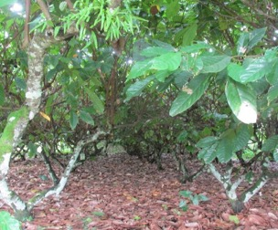
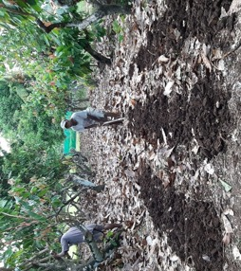
A
B
Figure 8A) Before half canopy pruning rehabilitation and 8B) Soil preparation for crop planting after half canopy removal (Nov.2019). Next unpruned canopy will be removed or pruned in 6-8 months time for cropping

    - Maintaining new regrowth- Normal management were conducted as in section 1.2.1.
2.2.3 Data collection: Yield data on the remaining half (50%) canopy and branches was done by counting ripe pods, mature pods and cherelles on a 6 monthly interval as in section 1.3.1.

- Progressive Results
3.1 Cropping Cycles
There were already 3 cropping cycles conducted in two alleys and 1 planted with rice. All the crops have grown well except round head cabbage variety KK cross which did not form the bigger heads as expected while some even failing to form heads. Nevertheless, this showed that this environmental condition and timing of planting was not suitable for this particular crop (round head cabbage) especially after two cycles already planted (Table 3) while the canopy closing in after shoots regrowth.

Table 3: Crops grown per cycle in each of the temporary Alleys or strips created.
Strip(Alley ) | NoCropping cycles | Cycle 1 &  2 crops Planted | Cycle 3 &  4crops Planted | Cycle 5 &  6 crops planted
Strip 1(Permenant) | 8 | Saladeer, Pachoi, Cassava | Peanut, Silver beet, Brocoli, Tomato | Pachoi.
Strip 2 | 3 | Saladeer, Lettuce,  Silver beet | Abika, Taro, Snake bean, Round cabbage
Strip 3 | 3 | Saladeer, Lettuce,  Silver beet | Abika, Taro, Snake bean, Round cabbage
Strip 4 | 1 | Rice
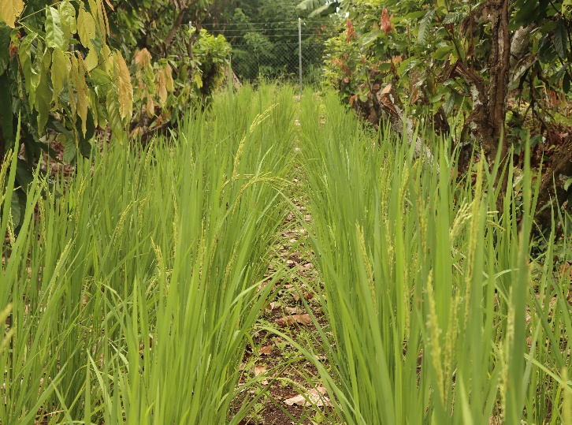
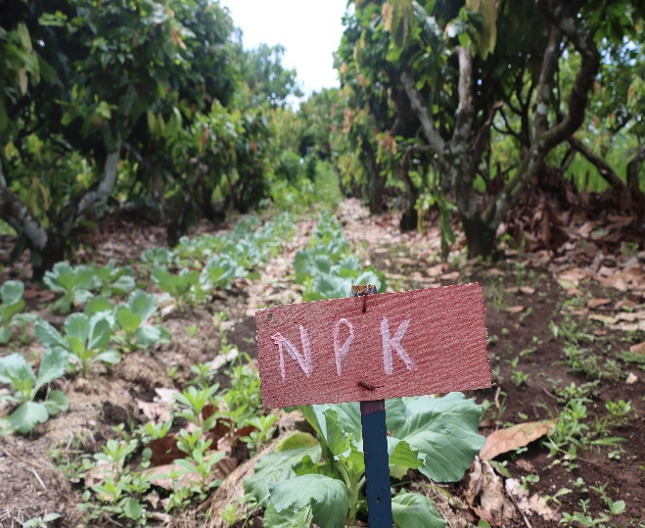
Figure 9A. First cycle planting with rice
Figure 9B. Third cycle planting with round head cabbage variety KK cross

By the month February march more half canopy rehabilitation pruning was conducted with intermediated size clones from former PNGCCRI. This had paved the way for more food crops for family and sale to be planted especially by women who were looking for a piece of land to plant.
This proves beyond doubt that food crops and /or vegetables integrated farming system through permanent and temporary alley cropping is possible with cocoa as long as the right done correctly. When this system is adopted it should assist in both nutrition and food security as well as improving yields of old senile cocoa stocks as indicated by the yield data

3.2 Cocoa Yields
The average yield of the half canopy pruned (HCP) treatment for the clones was 519kgdry bean/ha although individual clones 36-3/1 (621.1 kg dry bean/ha), 16-2/3 (531.6kg dry bean) and 34-14/4 (1067kg dry bean/ha) yielded higher (Table 2). The unpruned or control treatment comparatively had an average yield slightly higher (546.8 kg dry bean/Ha) than the HCP treatment. This suggests that the HCP treatment negatively impacted as expected the yield for the initial six (6) months period. This is probably due to the removal of half the “Would be “ productive branches so that in reality the negative impact greater than the recorded -5.4%. With proper statistical analysis there probably might be a non-significant effect of the HCP on yield or in other words the treat on HCP is highly recommended as it has no significant effect on Yield and the treatment was similar to the co0ntrol. Instead it may have more positive impacts on yield and on income earning opportunity and achieving some form of food security.
It is important to identify those clones that responded well to the treatment (HCP) can be identified as these are the potential clones to be looked at when thinking of rehabilitation of senile stock of cocoa. However, it is too early to make any conclusive selection. There is still 1.5 more years to monitor the yield and to make more conclusive statement.
3.3 Other benefits of rehabilitation
3.3.1 Firewood production
Firewood is essential for cooking and drying purposes for various things ranging from fish, pig meat and cocoa beans and others in rural communities as well as some urban areas. Current demand in buka/Kokopau townships show a bundle of firewood sales @ K12-K14/bundle and cocoa firewood will be no exception. During the rehabilitation there were lots of branches and trunks that were removed which valuable as they are an alternative source of income for farmers if they wish to sell them. One tree is estimated to produce 40-50kg fresh firewood with a value of approximately 20-kg dry woods selling at Buka town or in Arawa. This can be additional income from the cocoa trees after rehabilitation.
    - A development of crop rotation system
It is clear that as the 50% canopy regrows and close the alleys and the next unpruned 50% would be removed for cropping for the next 6-8 months thus the idea of crop rotation system is developed. The system can be practiced on all the rows available in the plantation or small holder block but does not have to be done all at once for example 10 percent of the plantation in one time until the old tree stocks are fully rehabilitated.
Table2: Ripe and mature pods and Cherelle counts, total estimated pods , Mean pods/tree, yield and yield changes on half (50%) canopy removal
Half canopy pruning | Tree  s/row |  | Counted numbers /row/clone |  |  |  | 30% conversi | Estimated total pod production¹⁾ | Mean pod/tree | pod wt | Wet bean percentage |  | YIELD  (Kg dry bean  /Ha²⁾ | + or _ change  (Kg) from control³⁾ | Percentage change
Big clones |  |  | ripe  pods |  | Mature pod | cherrels | cher to pods |  |  |  |  |  |  |  | (%)
34-14/4(r1) |  | 9.0 | 16.0 | 148.0 |  | 263.0 | 105.2 | 269.2 | 29.9 | 420.0 |  | 34.0 | 1067 | NC
36-3/1 |  | 8.0 | 5.0 | 26.0 |  | 134.0 | 67.0 | 98.0 | 12.3 | 780.0 |  | 26.0 | 621.1 | -156.2 | -20.1
16-2/3 (R1) |  | 8.0 | 4.0 | 30.0 |  | 121.0 | 60.5 | 94.5 | 11.8 | 600.0 |  | 30.0 | 531.6 | 102.7 | 24.0
34-14/4 (r2) |  | 8.0 | 9.0 | 25.0 |  | 120.0 | 48.0 | 82.0 | 10.3 | 420.0 |  | 34.0 | 365.9 | NC
16-3/2 |  | 9.0 | 10.0 | 12.0 |  | 75.0 | 37.5 | 59.5 | 6.6 | 600.0 |  | 28.0 | 277.7 | NC
73-2/2 |  | 8.0 | 2.0 | 8.0 |  | 86.0 | 43.0 | 53.0 | 6.6 | 520.0 |  | 29.0 | 249.8 | -517.2 | -207.1
Average | 8.3 |  | 7.7 | 41.5 |  | 133.2 | 60.2 | 109.4 | 12.9 | 556.7 |  | 30.2 | 519.0 | -27.8 | -5.4
Unpruned (Control)
37-13/1 | 12 |  | 23 | 71 |  | 101 | 30.3 | 124.3 | 10.4 | 780 | 26 |  | 525.1
16-2/3 | 10 |  | 19 | 51 |  | 107 | 32.1 | 102.1 | 10.2 | 600 | 28 |  | 428.0
73-2/2 | 8 |  | 5 | 45 |  | 46 | 13.8 | 63.8 | 8.0 | 450 | 30 |  | 269.1
36-3/1 | 9 |  | 18 | 85 |  | 135 | 40.5 | 143.5 | 15.9 | 780 | 26 |  | 777.2
73-2/2 | 8 |  | 15 | 129 |  | 284 | 85.2 | 229.2 | 28.7 | 450 | 30 |  | 767.0
37-13/1 | 9 |  | 9 | 53 |  | 97 | 29.1 | 91.1 | 10.1 | 780 | 26 |  | 513.2
Average | 9.3 |  | 14.8 | 72.3 |  | 128.3 | 38.5 | 125.7 | 13.9 | 640.0 | 27.7 |  | 546.8
Foot Note
NC=No control treatment for that clone, 1)=Counted at 6 months’ intervals on all trees/clone at April/May 2020. This takes into account the 5-6 months of flowering to pod ripening and harvesting period. Assumption that 30% of cherelles will mature to become ripe pods in 5 to 6 months, 2)=Estimated from total pods using various Yield components as shown in material & methods (section 1.3.1-1.3.4). Yield calculated from Mean pods/tree x Mean Pod weight of clone x % % Wet bean x Conversion factor of wet to dry bean (40%) x Plant density of 1000 trees/Ha (plant spacing of 4m x2.5m). 3)=Calculated as a difference of half canopy minus unpruned yi
through this demo for VEWs, surrounding farmers and public at large. It was also one of the objectives to find a systematic rehabilitation method with integrated food crop farming systems for food security, family health & nutritional and income diversification purposes. The preliminary work shows promising signs that the techniques developed and information generated would be useful for our VEWs and farmers.

4.1 Recommendation:
The following recommendations are made based of the preliminary findings of this study
  - Keep the monitoring of yield foe at least for the remaining years with the project to collect more data including those on chupon and fan branch shoot production, yield component measure and comparison to young aged trees and rate of canopy closure from half canopy re-growths
  - Make assessment of VEWs we are trialing this rehabilitation technique if there has been some improvements on yield
  - Include hybrid trees rehabilitation yield and some economic analysis the rehabilitation including diversification
  - More replicates is required to improve precision and upgrade the trial to a standard and formal trial to make good conclusion.
  - Include data on vegetable growth and sale income for the final report

5.0 References
Efron.Y, Epaina.P,Taisa.S.T (2003), Analysis of the factors affecting Yield variability in the SG2 Cocoa hybrid variety in Papua New Guinea, In Proceedings of the International Workshop on Cocoa Breeding for Improved Production Systems, Accra, Ghana, 19th-21st October 2003.
Efron, Y., Faure, M., Saul, J., & Blaha, G. (1996, November). Disease resistance studies and breeding in Papua New Guinea. In Ingenic workshop, Salvador, Bahia, Salao Porto da Barra, Brazil pp. 25-26.
Kouame.C,Yeboi.B,Tahi.M,Diomande.S,Kahia.J,N’zi.J.C,Diby.L, (2016), Assessing Rehabilitation efficiency of degraded Cocoa (Theobrama cacao,L.) farms in Cote d’Ivore, 2016 Next Generation Cocoa Research symposium, World Agroforestry Centre, Abidjan, Cote d’Ivoire.
Konam, J., Namaliu, Y., Daniel, R., & Guest, D. (2008). Integrated pest and disease management for sustainable cocoa production: a training manual for farmers and extension workers. Australian Centre for International Agricultural Research (ACIAR).
Montgomery PJ (1981). Some thoughts on the life span of cocoa.
Planter (Kuala Lumpur) 57: 604 – 9.
Shepherd CY (1955). Rehabilitation of cocoa plantations in Trinidad. In: DH Urgunart (ed) cocoa (2 nd Ed) Longman; London. 232-248
Wood, G.A.R. and Lass, R.A. (1985). COCOA (4th Ed.), Tropical agriculture series, Longman, Group Ltd, UK.

I have no explanation why there is no data for 2015

